Videos 15F1 – Energy Production Name
Energy Density:
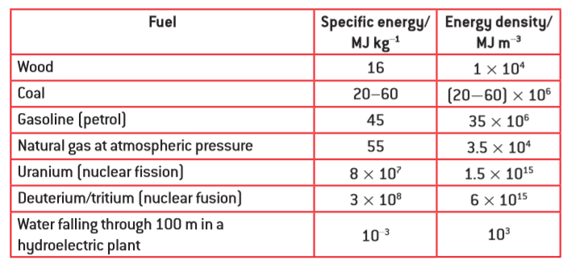
0. Energy Density: How many grams of petrol must you burn to release 100 kJ of energy?
(2.22 grams)

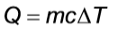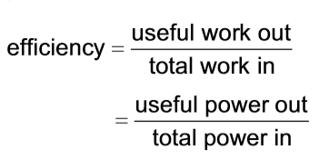

1. Heating Water: A water heater uses natural gas to heat 195 liters of water from 15.0 ºC to 59.0 ºC. What mass of natural gas would this take for a 100% efficient heater? What if the efficiency is 56.0%
(c_{water} = 4186 J kg⁻¹ ºC⁻¹) (0.653 kg, 1.17 kg)

2. Thermal Power Stations:

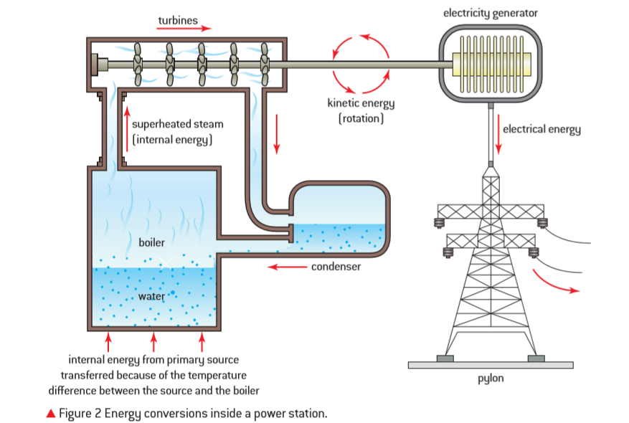
A coal fired electrical generation plant has an overall efficiency of 34.0% and generates an average of 180. MW of electrical power. What quantity of a coal with a specific energy of 47.0 MJ kg⁻¹ would this plant use in one week? (6.81x10⁶ kg)

Whiteboard 1: A water heater uses natural gas to heat 180. liters of water initially at 20.0 ºC. If the heater has an efficiency of 54.0%, what is the final temperature of the water after it has burned 0.500 kg of natural gas?
(c_{water} = 4186 J kg⁻¹ ºC⁻¹) (39.7 ºC)

Whiteboard 2: A natural gas electrical generation plant puts out an average of 312 MW of power for a year, and in the process, uses 4.36x10⁸ kg of natural gas. What is its overall efficiency? (41.0%)

3. Wind Turbines:
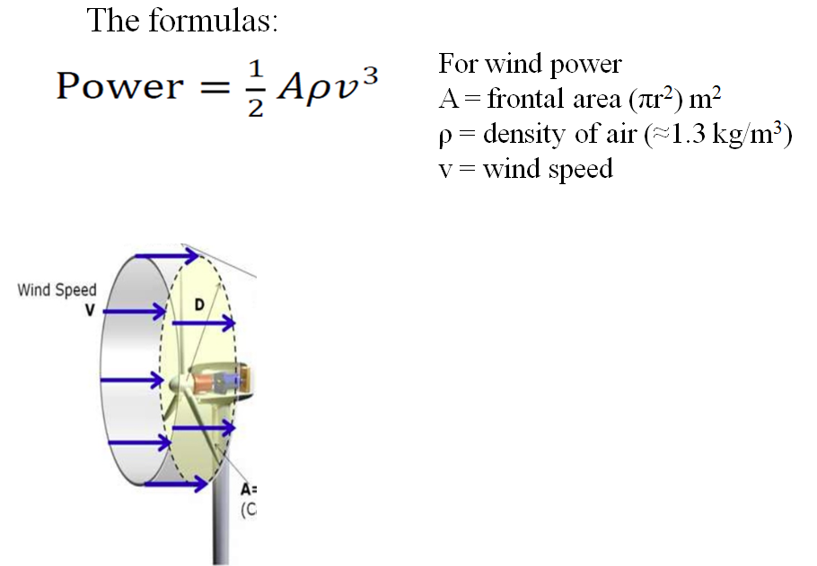

Ex1 – What max power can you get from a wind turbine with 8.2 m long blades when the wind speed is about 5.4 m/s on the average? Use the density of air to be 1.2 kg/m³ (2.0x10⁴ W)

Ex2 – What max power can you get from a wind turbine with 8.5 m long blades when the wind speed is about 7.3 m/s incident on the front of the blades, and is slowed to 6.5 m/s after the blades. Use the density of air to be 1.3 kg/m³ (1.7x10⁴ W)

Whiteboard: Your wind turbines have a radius of 9.70 m. They operate where the wind speed is 8.50 m/s, and they slow the wind to 7.60 m/s on their downwind side. Use the density of air to be 1.3 kgm⁻³
- What is the power output per turbine?
- How many turbines do you need to generate a megawatt of power? (1.00x10⁶ W)
(33652.26963 W ≈ 3.37x10⁴ W, 30 turbines)

4. Pumped Energy Storage:
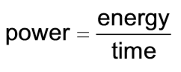
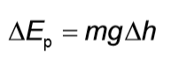
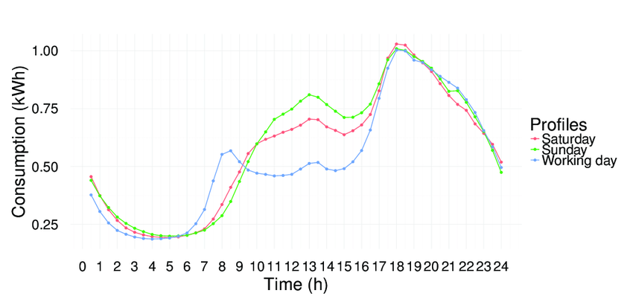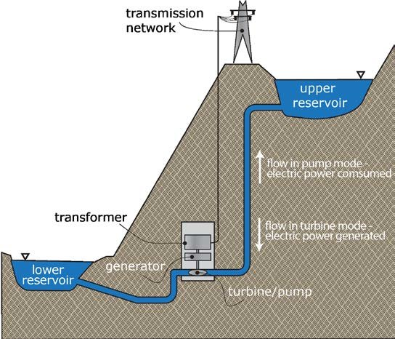
Example: A 65.0% efficient pumped storage plant uses a reservoir that is 196 m higher than the generation site. What is its electrical power output if it is draining water from the reservoir a a rate of 1250 kg s⁻¹? (1.56 MW)

Whiteboard: A pumped electrical storage facility generates 1.66 MW of power. It has a reservoir height of 130. m, and releases 2240 kg of water per second. What is its overall efficiency? (58.1%)

5. Solar:
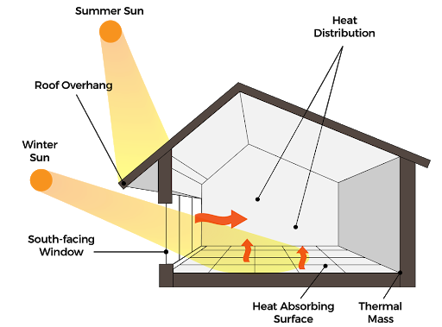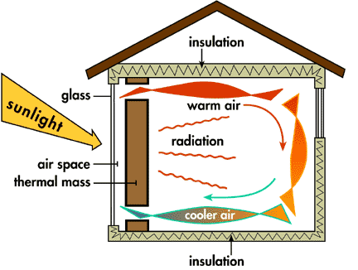
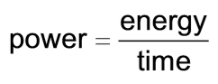
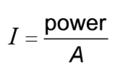
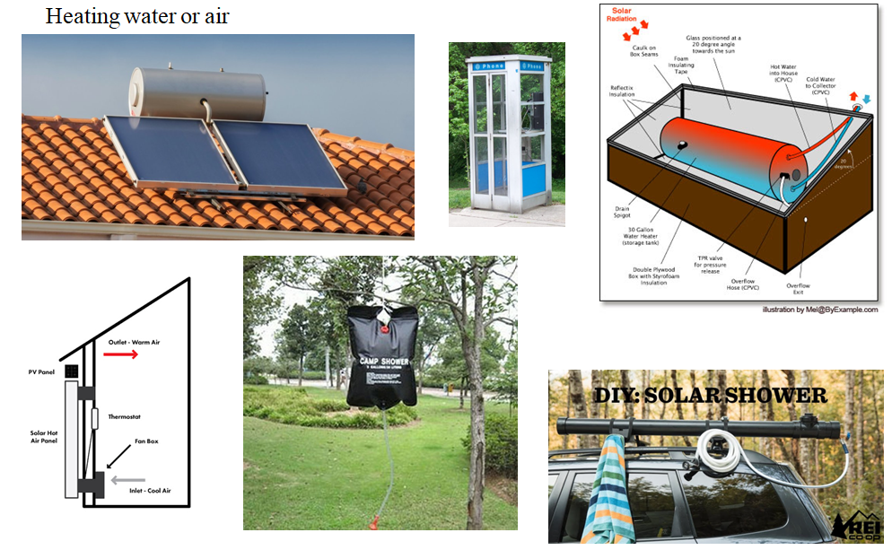
Example: A photovoltaic panel measures 1.75 m by 1.10 m, and is 23.0% efficient. How much total electrical power can it put out if the solar intensity is 890 W m⁻²? How many Joules of electrical energy can it produce in a 6.00 hour period when the sun is hitting the panels? How many kWh of electricity? (394 W, 8.51x10⁶ J, 2.36 kWh)

Whiteboard: A house has a total of 12.8 m² of solar panels that generate a power of 2045 Watts when the solar intensity is 750. W m⁻². What is the efficiency of the panels? (21.3 %)

