Videos 14L - Greenhouse Effect Name

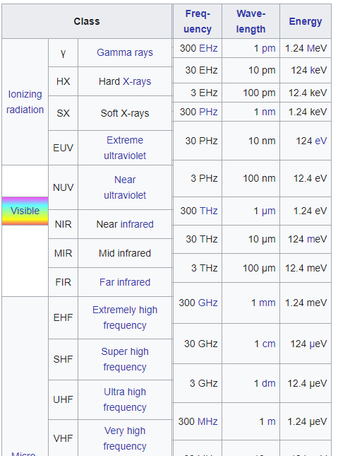
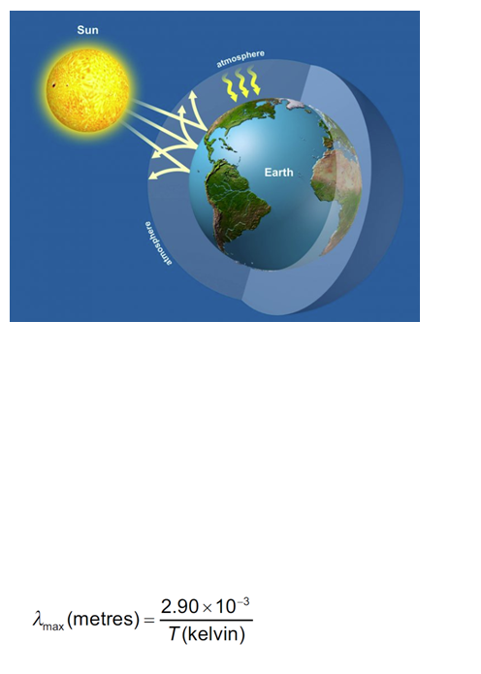

Ex 1: A star with a surface temperature of 5200 K has a radius of 6.5x10⁸ m, and is 1.7x10¹¹ m from a planet. Assume the star is a perfect black body. Calculate the intensity of the radiation in Wm⁻² incident on the planet’s upper atmosphere.

Ex 2: 606 Wm⁻² is incident on the upper atmosphere of a planet. If the planet’s upper atmosphere has an albedo of 0.23,
a) What portion of the light makes it to the surface?

b) What is the average intensity of light over the whole surface of the planet?

c) What would be the equilibrium temperature of the planet in space if there were no greenhouse effect?

