Videos 14K - Albedo Name
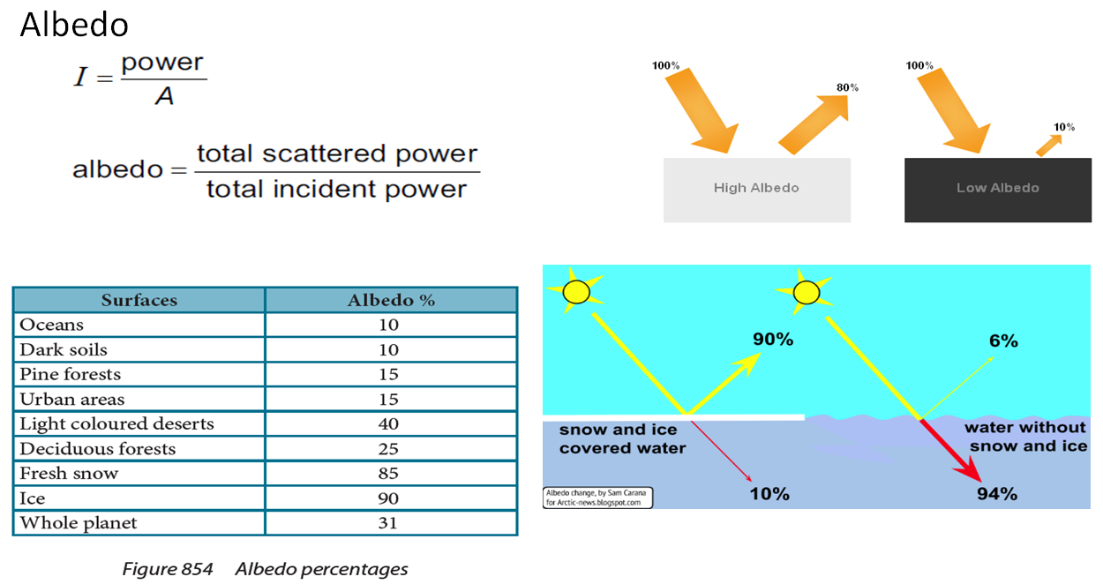

Ex – Sunlight of intensity 1030 Wm⁻² shines on a solar heater with an albedo of 6.20 % (0.0620)
What is the reflected intensity? What is the absorbed intensity?
What is the power absorbed if the heater has a surface area of 16 m²?

Try these:
On a day when the solar radiation is 980. W/m², how much power per square meter is reflected off into space from the oceans? How much is absorbed?
98.0 Wm⁻² reflected, 882 Wm⁻² absorbed

Do the same calculation for fresh snow. 833 Wm⁻² reflected, 147 Wm⁻² absorbed

