Videos 14J - Radiative Heat Transfer Name
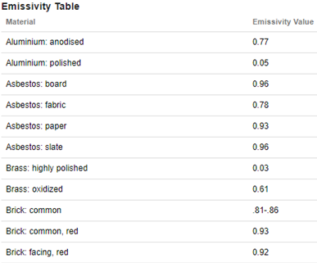
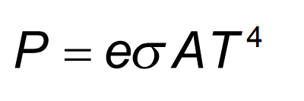

P - Rate of heat transfer in Watts
e - emissivity of object
σ - Stefan-Boltzmann constant - 5.67x10⁻⁸ Wm⁻²K⁻⁴
A - Radiative area in m²
T - Temperature in K

Ex1: A brick wall that has been warmed by the sun is at a temperature of 313 K, and measures 13 m long by 3.0 m high. At what rate does it radiate heat to the surroundings?

Ex2: An anodized aluminum sphere 20. cm in radius is used to radiate waste heat into space. What temperature does it need to be to radiate 800. W of heat?

Ex3: A transformer box has a surface area of 3.2 m² and is at a temperature of 39 ºC in a room where the surroundings are at a temperature of 20. ºC. What is the net rate of heat transfer from the box if its emissivity is 0.82?

