Videos 14I - Wien Displacement and Black Body Radiation Name

Black Body Radiation – electromagnetic waves emitted by all objects
(Radio, Micro, IR Light, UV, X-Ray, Gamma Ray)

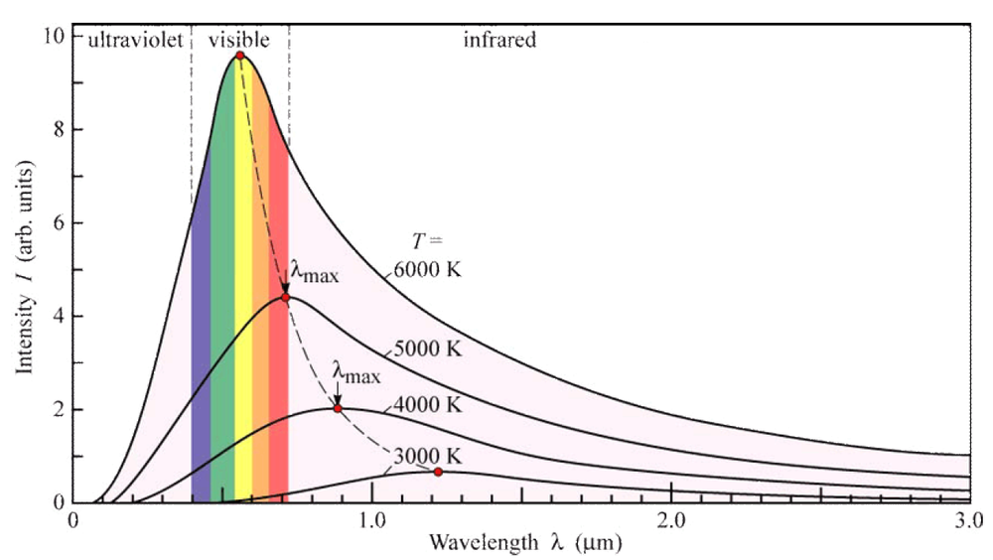

Ex: A star has a peak black body wavelength of 501 nm. What is its temperature? (5790 K)

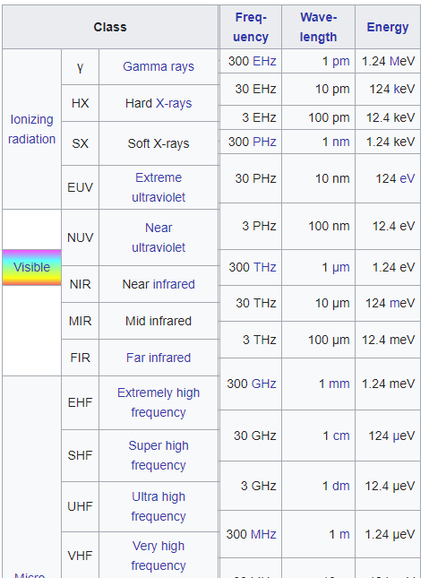

What is the peak radiation of the surface of ocean water
that is at 21.0 ºC? (9.86 μm)

