**Videos 14D – Phase Change Graphs Name**

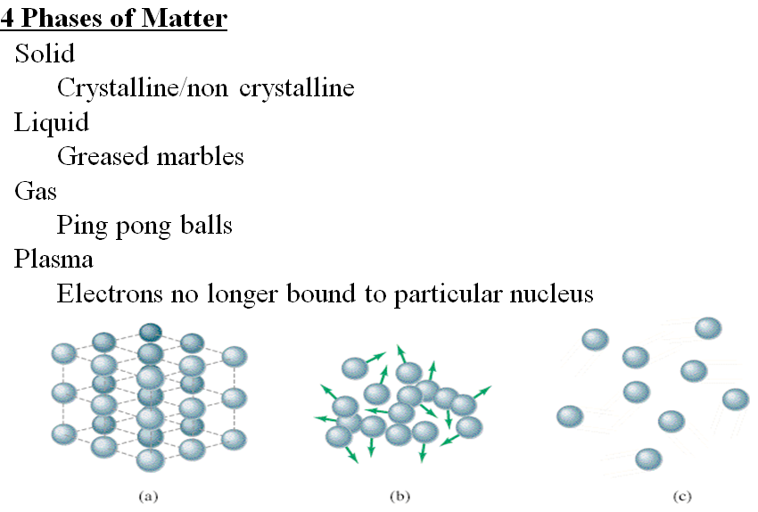

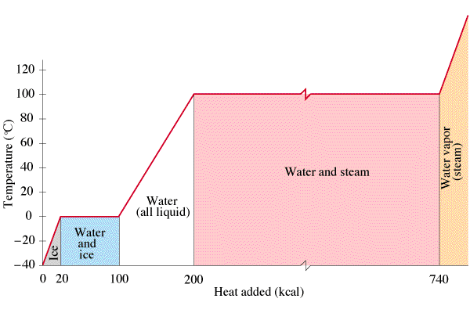

Example

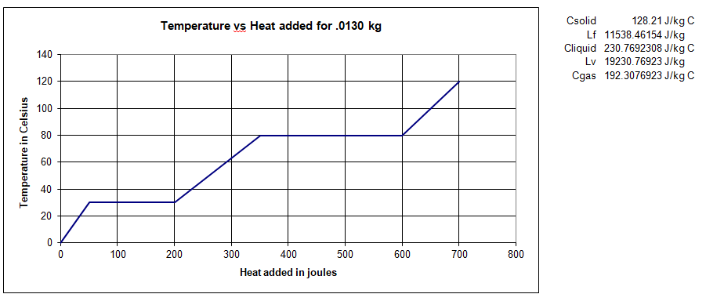



Whiteboards: (These are solved on the website in the videos linked after the main one)

|  |  |
| --- | --- |
| 1. What is the melting point and boiling point?  (25oC, 75oC) | 2. What is specific heat of the solid phase?  (440 J oC-1 kg-1) |
| 3. What is specific heat of the liquid phase?  (890 J oC-1 kg-1) | 4. What is specific heat of the gaseous phase?  (1480 J oC-1 kg-1)` |
| 5. What is the latent heat of fusion?  (22,000 J kg-1) | 6. What is the latent heat of vaporisation?  (56,000 J kg-1) |