Videos 14C – Latent Heat Name
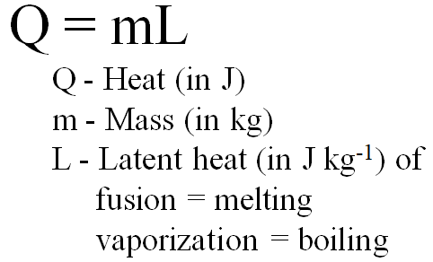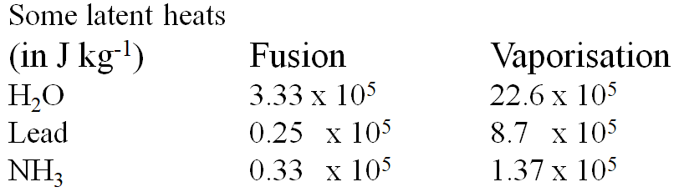

Example: Dewey Cheatham melts 4.51 kg of lead. What heat is needed? (1.1 x 10⁵ J )

Whiteboards: (These are solved on the website in the videos linked after the main one)
Take the time to go through #3 – those are the questions that are on the test!!!
1. Helen Highwater pumps 45 MJ (45 x 10⁶ J) of heat into some water at 100 ºC. How much boils away?  (20. kg ) | 2. Aaron Alysis has a 1500. Watt heater. What time will it take him to melt 12.0 kg of ice, assuming all of the heat goes into the water at 0 ºC  (2660 seconds )
3. Eileen Dover takes 1.42 kg of ice ( c = 2100 J ºC⁻¹kg⁻¹) from -40.0 ºC to water ( c = 4186 J ºC⁻¹kg⁻¹) at 20.0 ºC. What TOTAL heat is needed? (7.11 x 10⁵ J )

