Videos 13AB – Kinetic Theory and Temperature Name
13A – Kinetic Theory:

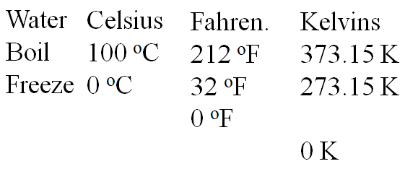
13B – Temperature Scales
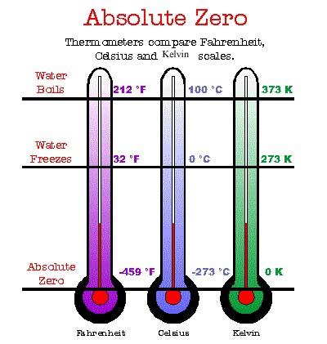

Write down the formula for converting:

Whiteboards: (These are solved on the website in the videos linked after the main one)
1. What is 37 ºC in Kelvins? (310 K) | 2. What is 77.35 K in ºC (-195.80 ºC)
3. What is 128 ºC in Kelvins? (401 K) | 4. What is 38 ºF in ºC (3.3 ºC)

