Practice for 12.2A
1. a-b: Two slits are separated by a small distance and are illuminated by 575 nm light. The interference pattern has bright fringes that are 1.13 cm apart on a screen that is 2.46 m away.
a. What distance separates the two slits? (0.125 mm)
b. What is the angle between the second order and the fifth order fringes on one side? (0.790º)
c. A single slit has a width of 0.130 mm and is illuminated by monochromatic light. A screen 1.51 m away has a pattern where the center of the central maximum is separated from the center of the next maximum by a distance of 0.857 cm. What is the wavelength of light? (492 nm)
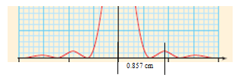
d-e: A diffraction grating has 6126 lines per cm. It is illuminated by a monochromatic light, and the central maximum and third order fringe are separated by 31.0º.
d. What is the wavelength of the light? (280 nm)
e. What is the smallest difference in wavelength this grating can resolve in the first order given a beam that is 1.80 mm wide, and 423 nm light? (0.384 nm)
2. a-b: Two slits are separated by a distance of 0.245 mm and are illuminated by monochromatic light. The interference pattern has bright fringes separated by 1.41 cm and falls on a screen that is 5.59 m away.
a. What is the wavelength of light? (618 nm)
b. What is the distance on the screen between the central maximum and the fourth order maximum? (5.64 cm)
c. A single slit has a width of 0.113 mm and is illuminated by 635 nm light. The interference pattern is projected on a screen that is 4.51 m away. What is the distance on the screen from the center of the first maximum on the left side to the center of the first maximum on right side? (7.60 cm)
d-e: A diffraction grating has 3852 lines per cm. It is illuminated by a 398 nm light beam that is 2.50 mm wide.
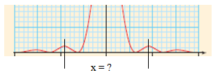
d. What angle separates the second order and the fourth order fringes? (20.0º)
e. For what wavelength of light could this setup resolve a difference of 0.410 nm in the first order? (395 nm)
3. a-b: Two slits are separated by a distance of 0.251 mm and are illuminated by 647 nm light. The interference pattern has fringes separated by a distance of 1.52 cm on a screen some distance away.
a. What is the distance to the screen? (5.90 m)
b. What is the angle between the central maximum and the fourth order maximum? (0.591º)
c. A single slit has a width of 0.0748 mm and is illuminated by 524 nm light. A screen some distance away has a central maximum pattern that is 3.24 cm wide. What is the distance to the screen? (2.31 m)
d-e: A diffraction grating is illuminated by a 428 nm light beam that is 1.60 mm wide. There is an angle of 3.58º between the central maximum and the second order fringe on one side.
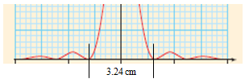
d. How many lines per cm does the grating have? (729 lines/cm)
e. What is the smallest difference in wavelength from 428 nm this setup can resolve in the first order? (3.67 nm)
4. a-b: Two slits are separated by a small distance and are illuminated by 478 nm light. The interference pattern has fringes separated by 1.65 cm on a screen that is 3.25 m away.
a. What distance separates the slits? (9.42x10⁻⁵ m)
b. What is the distance on the screen between the first order and the third order maximum on one side? (3.30 cm)
c. A single slit is illuminated by 524 nm light. A screen 4.20 m away has a central maximum pattern where the first minimum on one side is separated from the second by a distance of 1.26 cm. What is the width of the slit? (1.75x10⁻⁴ m)
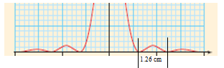
d-e: A diffraction grating has a distance of 4.80x10⁻⁶ m between lines. It is illuminated by a monochromatic light beam. There is an angular separation of 8.13º between the central maximum and the first order fringe.
d. What is the wavelength of light? (679 nm)
e. How wide does the beam of light have to be to resolve the two wavelengths 421.171 nm and 421.201 nm in the second order using the same diffraction grating? (3.37 cm)
5. a-b: Two slits are separated by a distance of 0.280 mm and are illuminated by 652 nm light. The interference pattern falls on a screen that is 2.06 m away.
a. What distance separates the fringes on the screen? (0.480 cm)
b. What is the angle between the central maximum and the second order maximum? (0.267º)
c. A single slit has a width of 0.152 mm and is illuminated by 740 nm light. The interference pattern is projected on a screen that is 2.57 m away. What is the distance on the screen from the center of the central maximum to the center of the second maximum on one side? (3.13 cm)
d-e: A diffraction grating is illuminated by a 596 nm light. There is an angle of 38.2º between the central maximum and the third order fringe on one side.
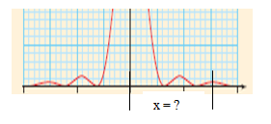
d. How many lines per cm does the grating have? (3459 lines/cm)
e. How wide does the beam of light have to be to resolve the two wavelengths 512.174 nm and 512.286 nm in the first order using the same diffraction grating? (1.32 cm)

