IB Physics
Simple Harmonic Motion and Waves
 | A/B | Class | Due on this class
 | 1  Apr  4/5 | DI-SHM Demos  GW-P11.1 #1-15 | VF 11A
 | 2  Apr  8/9 | DI-Resonance  GW-P11.1 #16-25  GW-FA11.1 | VF 11B, 11D
 | 3  Apr  10/11 | SA11.1-Simple Harmonic Motion (first 30)  VF-11E, 12A, 12B, 12C (Basic Waves) | Turn in FA11.1
 | 4  Apr  15/16 | DI-Basic Waves  GW-Resonant Systems Lab | VF 11E, 12A, 12B, 12C
 | 5  Apr  17/18 | DI-Waves, Interference, Young's Double slit  GW-Waves Lab | VF 12D, 12E, 12F
 | 6  Apr  19/22 | DI-Standing Waves Demos  GW-Standing Waves problems | VF 12G
 | 7  Apr  23/24 | SA12.1-Standing Waves (first 30)  VF 12H - Doppler  DI-Doppler/Sonic Boom | Turn in FA12.1
 | 8  Apr  25/26 | GW-Doppler Effect (12.2)  DI-Music and Beats | VF 12H, 12I
 | 9  Apr  29/30 | SA12.2-Doppler Effect (first 30)  VF 12J, 12K, 12L | Turn in FA12.2
 | 10  May  1/2 | DI-Oaks Park Prep  GW-Refraction | VF 12J, 12K, 12L
 | 11  May  3/6 | DI-Polarization  GW-Diffraction and Rayleigh | VF 12M, 12N, 12O  Turn in FA12.3 (no summative)
 | May  8/9 | Oaks Park Prep | VF 12P, 12Q
 | May  10 | Oaks Park Day!!!!!!!
 | May  13/14 | Work on Presentations
 | May  15/16 | Oaks Park Presentations to class
4 Formative Assessments/3 Summative:
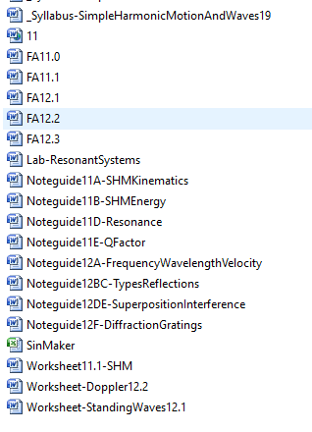
- 11.1 – Simple Harmonic Motion
- 12.1 – Standing Waves
- 12.2 – Doppler and interference
- 12.3 – Refraction (Formative Only)
A Cumulative Final (Don't freak out - I will tell you exactly what is on it)
Two Labs:
- Sound lab – Your own procedure – done in class. No handout.
- Oaks Park – Student presentations of analysis of work done at Oaks Park

