P12.3 – Refraction and Critical Angle Problems.

0. Sound travels at 1498 m/s in water, and 343 m/s in the air. An explosion occurs on the surface of the water 1250 m away. What time does it take the sound to reach you in the air? What time does it take the sound to reach you in the water? What amount of time separates the arrival of the sound in the water and in the air?
(Air: 3.644 s, Water: 0.834 s, Difference: 2.81 s)

1. A 632.8 nm laser has an incident angle of 45.0º in air and strikes some oil with an index of refraction of 1.54.
a. What is the frequency of the laser? (4.74x10¹⁴ Hz)
b. What is the wavelength of the laser in the oil? (411 nm)
c. What is the refracted angle in the oil? (27.3º)
d. What is the critical angle at the oil air interface? In which medium does the critical angle occur?
(40.5º, in the oil – the slower medium)

2. Light has a wavelength of 356 nm in glass. It passes from the glass into water with an index of refraction of 1.33. The incident angle in the glass is 29.0º and the refracted angle in the water is 37.0º.
a. What is the index of refraction of the glass? (1.65)
b. What is the wavelength of the light in the water? (442 nm)
c. What is the critical angle of the glass water interface? In which medium does it occur?
(53.7º, in the glass – the slower medium)

3. Find the index: (2.06)  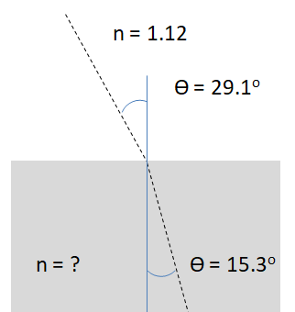 | 4. Find the angle: (40.3º)  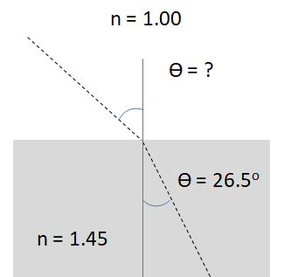 | 5. Find the angle: (66.4º)  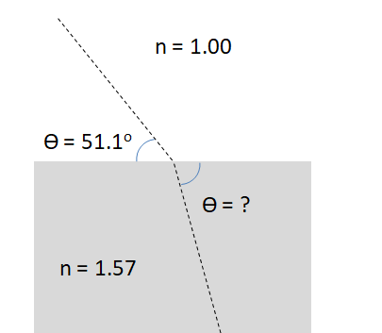

6. Super challenge. A horizontal beam of light strikes the isosceles prism below.
a. What angle does the emergent beam make with the horizontal? (23.2º below the horizontal)
b. What maximum index of refraction can the prism have for the beam to exit the prism on the right side? (1.97)

