Doppler Effect Problems Like 12.2

A. Doppler Problems: (Use 343 m/s as the speed of sound.)
 | Moving Source: Moving Observer:
262.2 Hz | 1. A car with a horn frequency of 240 Hz approaches you at 29 m/s. What frequency do you hear?
136.1 Hz | 2. A person hums at 150 Hz while driving away from you at 35 m/s. What frequency do you hear?
344.6 Hz | 3. Your dad is singing at 356 Hz, and you run away from him at 11 m/s. What frequency do you hear?
995.5 Hz | 4. You are riding on a train going 45 m/s. As you approach a crossing, there is a bell with a frequency of 880 Hz. What frequency do you hear?
187.3 Hz | 5. A salsa band is running away from you at 14 m/s. If you hear a pitch of 180 Hz, what frequency are they really playing?
390.6 Hz | 6. You hear a pitch of 420 Hz as a car with a man standing on the roof playing a flugelhorn approaches you at 24 m/s. What frequency is the man really creating?
442.5 Hz | 7. You are riding a rocket-propelled skateboard at 57 m/s toward a television playing a Lawrence Welk re-run. If you hear a pitch of 516 Hz, what is the real pitch the television is making?
92.7 Hz | 8. You are in a motorboat going 21 m/s away from a foghorn. You hear it at a pitch of 87 Hz, so what pitch is it really creating?
10.8 m/s away | 9. If you hear a frequency of 253 Hz as you listen to a middle C (261 Hz) being played on a piano that is on a flatbed train car, is the car going toward you or away, and how fast?
9.2 m/s toward | 10. If a car 217 Hz car horn is heard at 223 Hz, is the car approaching you or receding from you, and what is its speed?
17.5 m/s away | 11. You are riding in a train with a blindfold on, and you hear an 880 Hz crossing bell, but it appears to have a pitch of only 835 Hz. Are you moving toward or away from the bell, and how fast?
27.3 m/s toward | 12. How fast and in what direction (away or toward) do you have to run relative to a concertmaster playing an A 440 Hz so that you hear it at 475 Hz?
388.4 Hz | 13. You are driving at 27 m/s toward an oncoming driver on a highway. They are approaching you at 43 m/s. (a tad in excess of the speed limit) You honk at them with your 318 Hz horn to indicate your dissatisfaction with their driving habits. What frequency do they hear?
453.4 Hz | 14. You are driving your Porsche at 57 m/s on the Autobahn and you come behind a Prius in the left lane going only 35 m/s. You honk your 421 Hz horn at them. What frequency do they hear?
94,900.3 Hz | 15. A bat flying at 17 m/s is approaching a moth flying toward the bat at 7.0 m/s. If the bat generates an echolocation frequency of 82,500 Hz, what frequency does the bat hear reflected off the moth?

B. Interference Problems: (Use 343 m/s as the speed of sound.)

1. Two speakers 4.10 m apart are in phase at 512 Hz. If I am 4.00 m from one speaker, and 6.68 m from the other, what is the wavelength, and how many wavelengths difference is the distance, and is it constructive (loud) or destructive (quiet) interference? (λ= 0.670 m, 4 λ, Constructive)
2. Two speakers 4.50 m apart are in phase at 256. Hz. If I am 3.00 m from one speaker, and 6.35 m from the other, what is the wavelength, and how many wavelengths difference is the distance, and is it constructive (loud) or destructive (quiet) interference? (λ= 1.34 m, 2.5 λ, Destructive)
3. Two speakers 5.00 m apart are in phase at 1024. Hz. If I am 8.42 m from one speaker, and 9.59 m from the other, what is the wavelength, and how many wavelengths difference is the distance, and is it constructive (loud) or destructive (quiet) interference? (λ= 0.335 m, 3.5 λ, Destructive)

4. These two sources A and B are in phase, and generate a sound wave with a frequency of 625 Hz. Calculate the wavelength, and for the two positions p and q, indicate the path length difference in wavelengths, and whether it would be constructive or destructive interference.
(λ = 0.549 m, p: 1.5 λ Destructive, q: 1.0 λ Constructive)
5. These two sources A and B are in phase, and generate a sound wave with a frequency of 631 Hz. Calculate the wavelength, and for the two positions p and q, indicate the path length difference in wavelengths, and whether it would be constructive or destructive interference.
(λ = 0.544 m, p: 1.5 λ Destructive, q: 1.0 λ Constructive)
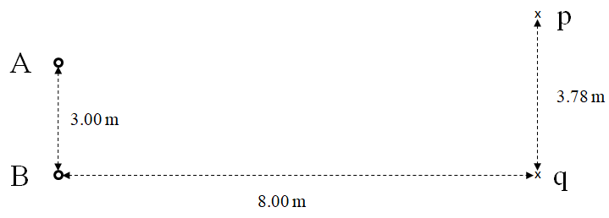
6. These two sources A and B are in phase, and generate a sound wave with a frequency of 2115 Hz. Calculate the wavelength, and for the two positions p and q, indicate the path length difference in wavelengths, and whether it would be constructive or destructive interference.
(λ = 0.162 m, p: 2.5 λ Destructive, q: 8.5 λ Destructive)

