Noteguide for Polarization (Videos 12P) Name

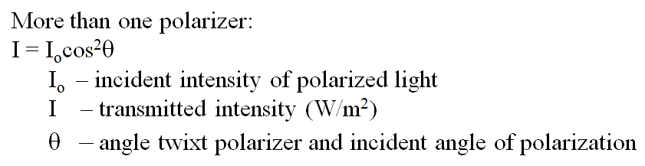
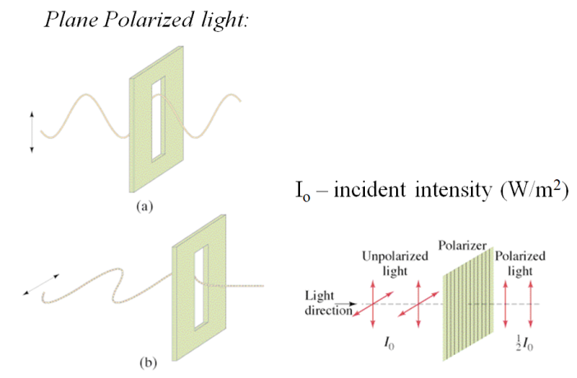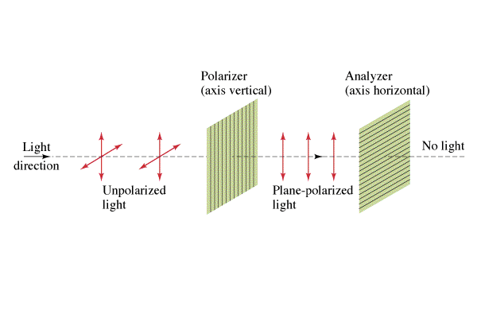

Two polarizers are at an angle of 37º with each other. If there is a 235 W/m² beam of light incident on the first filter, what is the intensity between the filters, and after the second?

Whiteboards:
1. 120. W/m² of vertically polarized light goes through a filter that makes an angle of 21.0º with the vertical. What is the transmitted intensity? (105 W/m²) | 2. 120. W/m² of vertically polarized light goes through a filter that makes some angle with the vertical such that only 80.0 W/m² are transmitted. What angle does the filter make with the vertical? (35.3º)
3. 500. W/m² of UNpolarized light goes through a vertically polarized filter, and then through one the makes an angle of 68.0º with the vertical. What is the transmitted intensity?

