Noteguide for Diffraction Grating Resolution (Videos 12O) Name

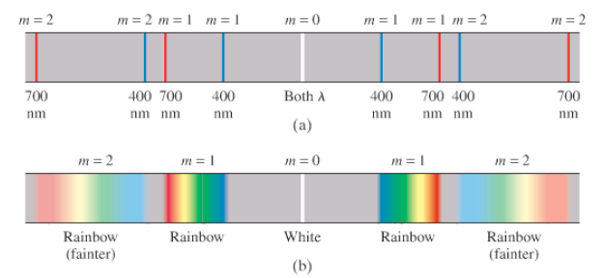
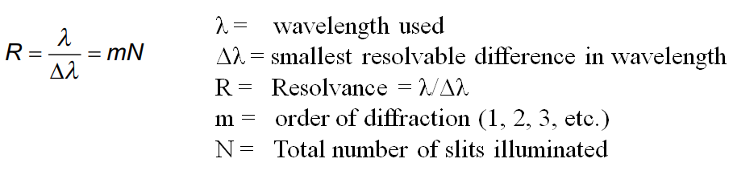

Example:
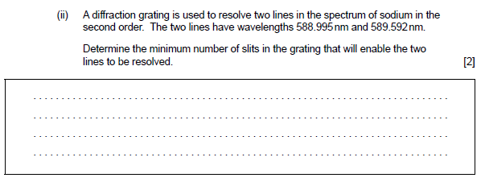

Whiteboards:
1. 632.8 nm light illuminates 742 slits in a diffraction grating. What is the smallest difference in wavelength difference from this wavelength that the grating can resolve in the first order? (0.853 nm)

2. 985 slits in a diffraction grating can resolve in its second order a wavelength difference of 0.350 nm. What must be the wavelength of the light? (689.5 nm)

