Noteguide for Index of Refraction (Videos 12J) Name
c = 3.00 x 10⁸ m/s in a vacuum Light is slower in other materials
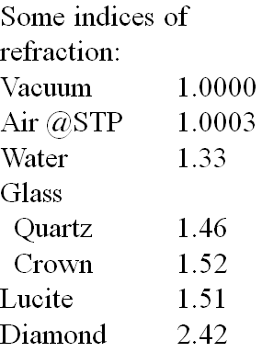
Index of refraction:

n = c/v

c = 3.00 x 10⁸ m/s
v = speed in particular medium (m/s)
n = index of refraction (no units!!!)

The bigger n is, the slower light travels

Example:
What is the speed of light in water? n = 1.33

Whiteboards:
1. What is the index of refraction of a substance where the speed of light is 2.3 x 10⁸ m/s? (1.30) | 2. What is the speed of light in diamond? n = 2.42  (1.24x10⁸ m/s)
3. What is the wavelength of 720. nm light in a diamond? n = 2.42 (720. nm is its wavelength in a vacuum, the frequency remains the same) Find the frequency in a vacuum (v = fλ), find the velocity in diamond (See #2), find the wavelength in the diamond (v = fλ). Then, after doing all that, multiply 720 by 1.00/2.42 (the ratio of the indices)
(298 nm)

