**Noteguide for Standing Waves (Videos G, Part 1) Name**

**Watch the demos of all three kinds first**

**Intro to standing waves -**

Draw the next two modes: (from the video)

|  |  |  |  |
| --- | --- | --- | --- |
| **Harmonic** | **Both ends fixed** | **Both ends free** | **One end fixed** |
| **1** | **4Antinodes** | **4Antinodes** | **4Antinodes** |
| **2** |  |  |  |
| **3** |  |  |  |

Haha - we will talk in class **why** they happen. (I try to explain it on the video)

**Calculations with standing waves**

One whole wavelength: 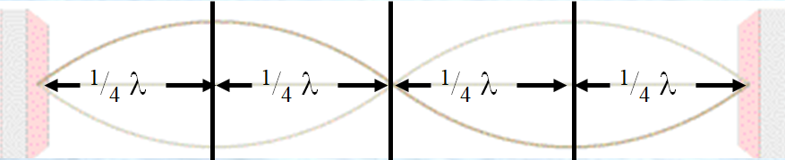

So a quarter wavelength is either:

** OR  Formulas:**  

So count the quarter wavelengths:

|  |  |
| --- | --- |
| 4Antinodes | 4Antinodes |
| 4Antinodes | 4Antinodes |

  **Formulas:**  

Example: This waveform is 8.45 m long. What is the wavelength of the standing wave? If it has a frequency of 30.4 Hz, what is the wave speed?

What is meant by the **waveform**: What is meant by the **wavelength**:

Do **all** of the examples

|  |  |
| --- | --- |
| 4Antinodes  This **waveform** is 45 cm long. What is the wavelength? | 4Antinodes  The **wavelength** is 0.80 m long. What is the length of the standing wave? (The waveform) |
| 4Antinodes  This **waveform** is 2.42 m long. What is the wavelength? If it is a sound wave (v = 343 m/s), what is the frequency? | 4Antinodes  The **wavelength** is 124 cm long. What is the length of the waveform?  If it is a sound wave (v = 343 m/s), what is its frequency |