Noteguide for Single Slit Interference Patterns (Videos 12F2) Name
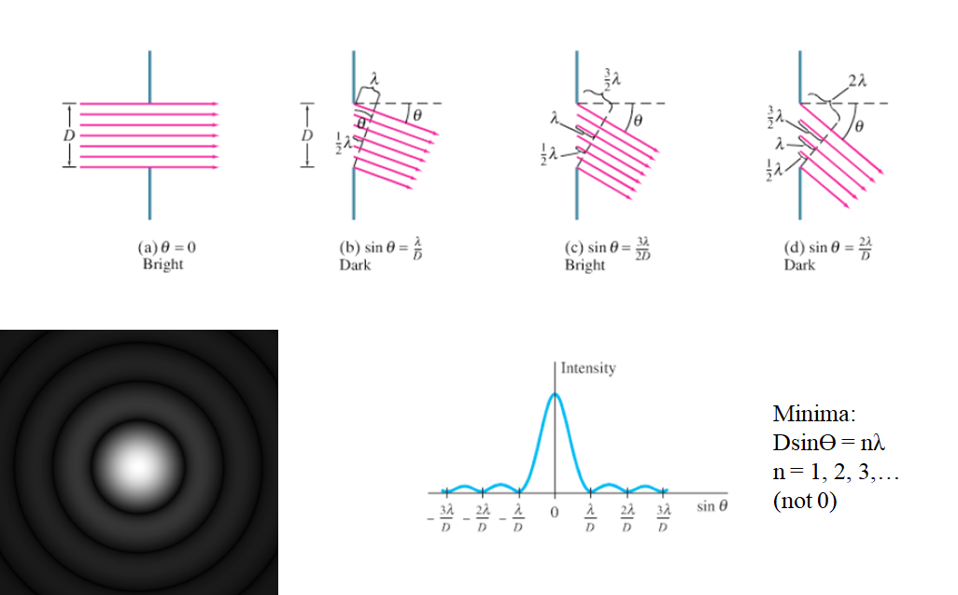

Write down what all the variables are:

Example: If 644 nm light falls on a slit 0.0560 mm wide,
A. What is the full angular width of the central diffraction peak?

B. What is its width on a screen that is 4.50 m away?

C. What distance separates the central maximum from the third minimum on the screen 4.50 m away?

Whiteboard 1: Monochromatic light falls on a slit that is 0.00320 mm wide. The angle between the central maximum and the second dark fringe on one side is 18.0º. What is the wavelength of light used? (4.94x10⁻⁷ m (494 nm) )

Whiteboard 2: When blue light of wavelength 462 nm falls on a single slit, the first dark bands on either side are separated by 43.0º. Determine the width of the slit. (1.26x10⁻⁶ m (1.26 μm) )

