Noteguide for Double Slit Interference Patterns (Videos 12F1) Name
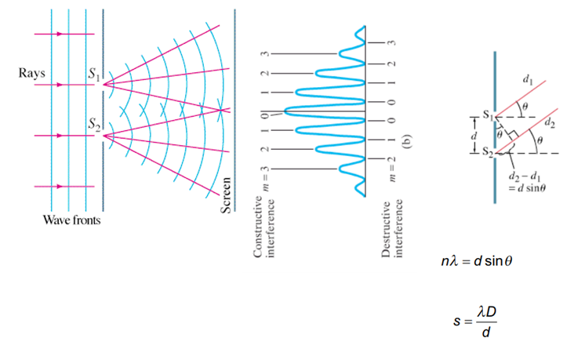
Write down what all the variables are:

Example 1: A Parallel beam of light from a laser with a wavelength of 638 nm falls on two very narrow slits 0.0550 mm apart.
A. How far apart are the fringes on the center of a screen 4.30 m away?

B. What angle separates the central fringe, and the fifth order fringe? What distance is this on the screen?

C. What distance separates the central fringe and the and the first minimum (destructive) location?

Example 2: The third order fringe of 620. nm light is observed at an angle of 21.0º when the light falls on two narrow slits.
A. What distance separates the slits?

B. What angle does the second order fringe make with the central fringe? What distance separates the central bright spot and the second order fringe on a screen 5.00 m away?

Whiteboard 1: Monochromatic light falls on two very narrow slits 0.0450 mm apart. Successive fringes on a screen 6.00 m away are 7.20 cm apart. Determine the wavelength and the frequency of the light.

Whiteboard 2: Two narrow slits are separated by 1.00 mm are illuminated by 544 nm light. Find the distance between adjacent bright fringes on a screen 3.40 m away.

What angle separates the central bright spot and the 4th order fringe?

