Noteguide for Intensity and Amplitude (Videos 12D1) Name

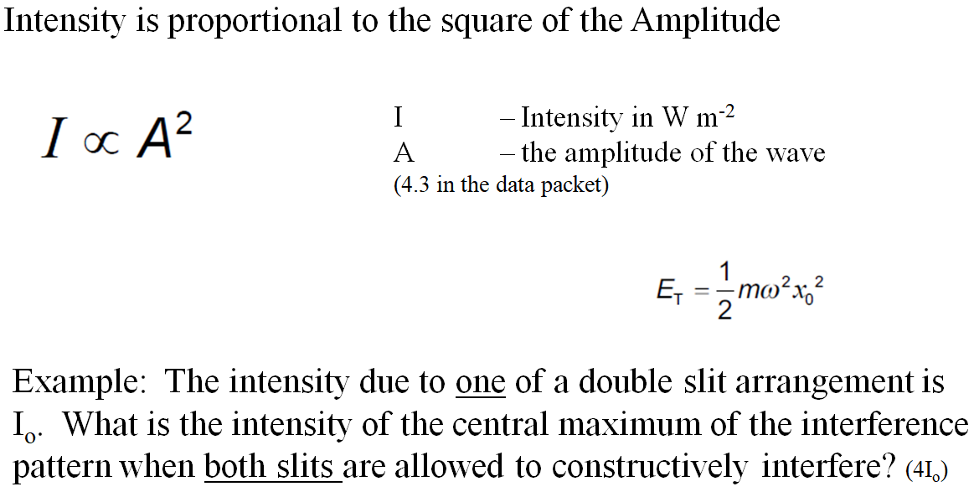

Whiteboards
1. Three narrow slits close together are illuminated by light. The intensity at the center of the three on a distant screen is  23.8 μW m⁻² due to the light from one of the slits. What is the intensity if all three constructively interfere at the center?  (2.14x10⁻⁴ W m⁻²) | 2. A number of narrow slits close together are illuminated by light. When only one of the slits illuminates the screen, the central bright spot has an intensity of I_{o}. When all of the slits illuminate the screen, the intensity is 25I_{o} in the center.. How many slits are there?  (5)
3. Light from a heat lamp has an intensity of 467 W m⁻². If we were to double the amplitude of the light wave, what would be its intensity?
(1868 W m⁻²)

