Noteguide for Intensity and Inverse Square (Videos 12C1) Name
Concept 0: The Definition of Intensity:

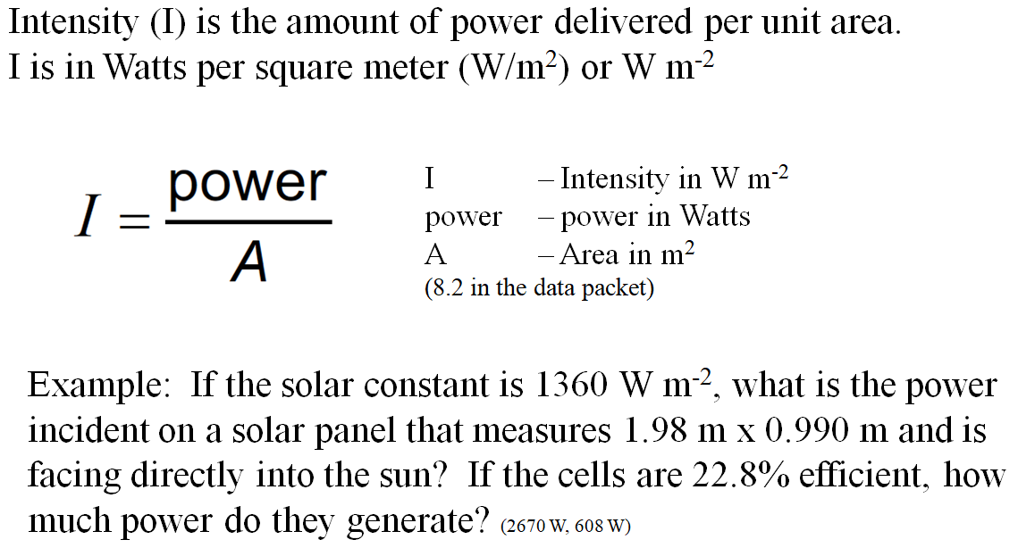

Whiteboards
1. A sunlamp projects 45.0 Watts of power onto a piece of metal that measures 34.0 cm x 67.0 cm. What is the intensity of the light?  (198 Wm⁻²) | 2. On a winter day in Oregon, the solar flux is 365 Wm-2. What is the total power incident on a roof that measures 12.5 m by 45.5 m and is angled cleverly so that it is perpendicular to the sun’s rays!!? (208 kW)
3. You are designing a solar array for your house. You want to generate 5000. W of electricity on a sunny 980. W m⁻² day, but since your solar panels are only 22.8% efficient, you will need to capture 21,930 Watts of solar flux. What area is required to capture this amount of solar flux?
(22.4 m²)

Concept 1: The Inverse Square Law:

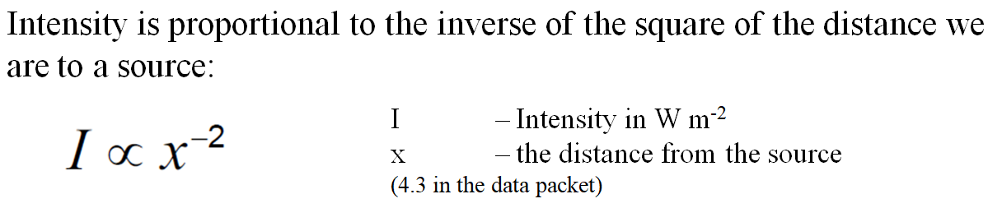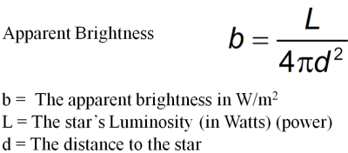

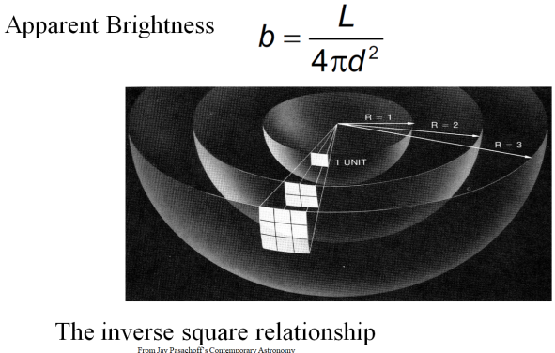
Example: If we are 204 cm from a source our intensity is 12.0 W m⁻². What would be our intensity if we were to move to 68.0 cm from the same source? (108 W m⁻²)

Whiteboards:
1. A sound source that is 4.50 m from us is hitting us with 3.40 mW m⁻² of power. What is the intensity if we were 6.70 m from it?  (1.53 mW m⁻²) | 2. The intensity from a bright light is 260. W m⁻² when we are 3.85 m from it. At what distance would it be 450. W m⁻²?  (2.93 m)
3. What distance from a 60.0 W light source is the intensity 12.0 mW m⁻²? (19.9 m)

