Noteguide for Damping and Q Factor (Videos 11E) Name
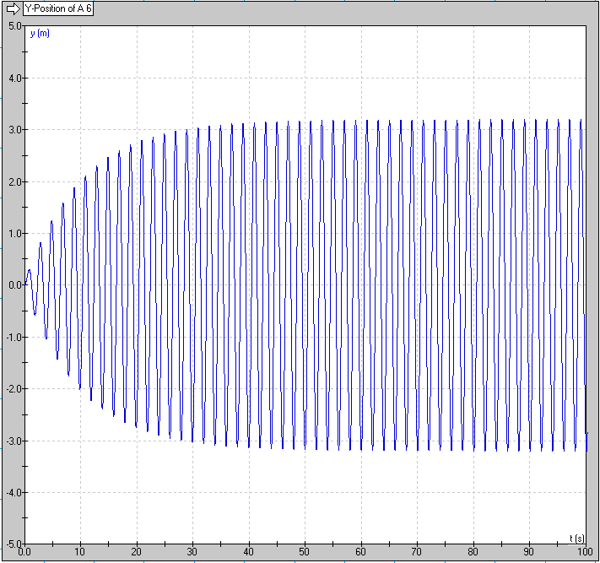
Damping in General:
0-40 seconds:

40-infinity seconds:

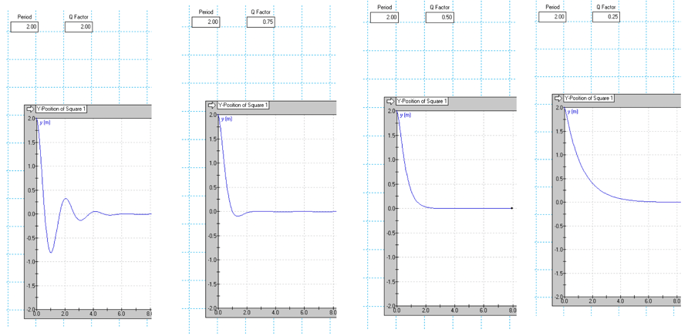
Critical Damping

Q factor Demo - What is the basic idea behind Q factor? Is a high or low Q factor heavily damped?
Is a high or low Q factor lightly damped?
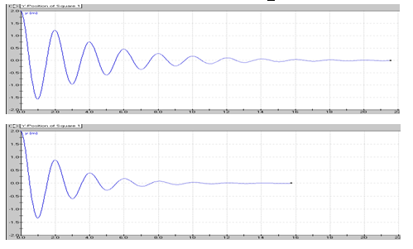

Q =

Q =

Calculations:
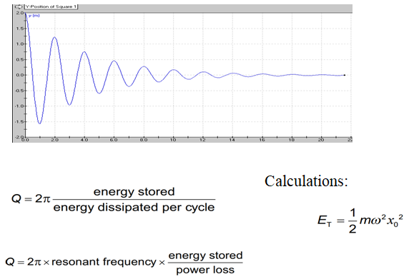
Write down the sample calculation I do here:

