Noteguide for Resonance (Videos 11D) Name
In resonance - there is a driving frequency, and a resonant or natural frequency.
Watch the first two short videos. What must be true about the driving and natural frequencies for there to be resonance?

Resonance and Damping:
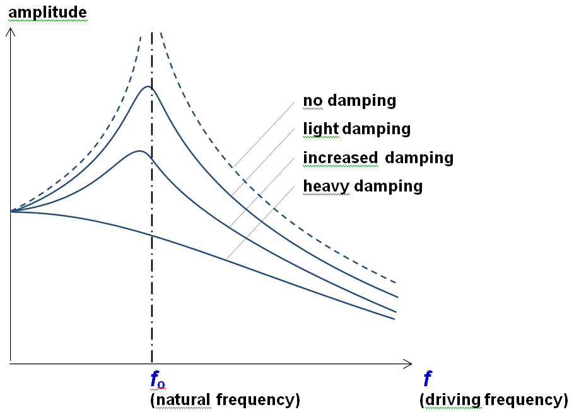
Two things happen when there is more damping (friction)

1.

2.

Phase lag and resonance: (Watch the demo video first, then the main video)
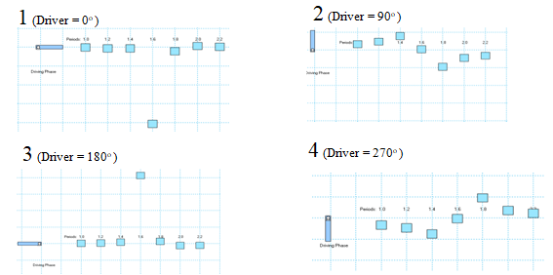
Faster oscillators are:

Resonant oscillators are:

Slower oscillators are:

Interpreting Phase lag graphs:
