Noteguide for Standing Waves (Videos 12G, Part 2) Name
Video G Part 2 - First three modes of vibration
This string is 32.0 cm long, and has a wave speed of 281.6 m/s. Find the wavelength and frequency for each mode:
 | Wavelength | Frequency
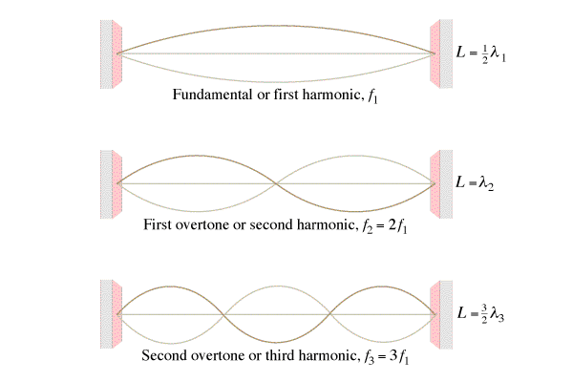
What is the pattern of frequencies:

This pipe is 1.715 m long, sound travels at 343 m/s along the pipe. Find the wavelength and frequency for each mode:
 | Wavelength | Frequency
What is the pattern of frequencies:

This pipe is 1.715 m long, sound travels at 343 m/s along the pipe. Find the wavelength and frequency for each mode:
 | Wavelength | Frequency
What is the pattern of frequencies:

Whiteboards:
1. The third harmonic on a flute (both ends open pipe) has a frequency of 480. Hz. How long is the waveform if the speed of sound inside the flute is 335 m/s?  (1.05 m) | 2. What is the frequency of the 2nd harmonic on a 0.31 m long pan pipe (One end open, one end closed) where the speed of sound is 343 m/s (829.8 Hz)
3. What is the wave speed on a 0.34m long violin string if the first harmonic has a frequency of 440 Hz?  (299.2 m/s) | 4. What is the frequency of the 3rd harmonic on a violin string that is 0.34 m long where the wave speed is 299.2 m/s (1320 Hz)

