IB Physics
FA11.0 - Simple Harmonic Motion Graphs

Name

What your parents call you when they are cheesed off
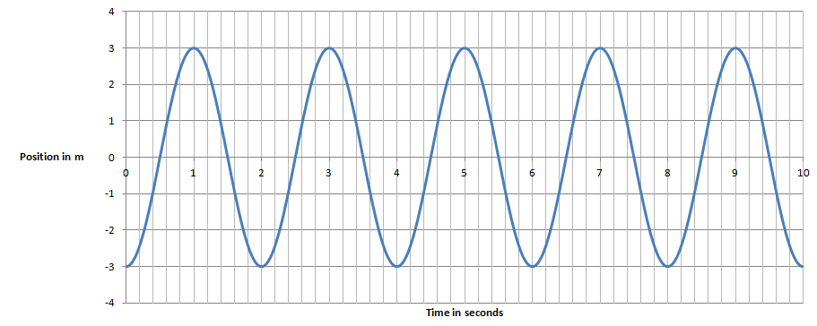

Given this graph of position vs. time for a SHO, determine:

1. Period = Amplitude =

2. Write an equation for its position:

3. Write an equation for its velocity: (EC - write one for its acceleration)

4. At 4.2 seconds what is its position, velocity and acceleration?

5. Fill in the table qualitatively: (+ or - or 0)
Time | x | v | a
3.0 s
1.5 s
2.4 s
3.8 s
4.5 s
4.0 s

