Videos 10K, L, M – Viscosity, Stokes, and Reynolds Numbers Name

10K
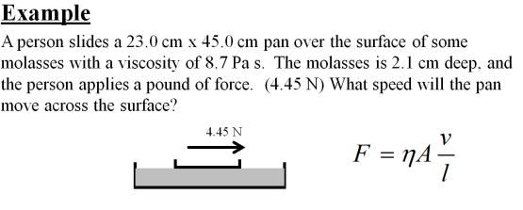
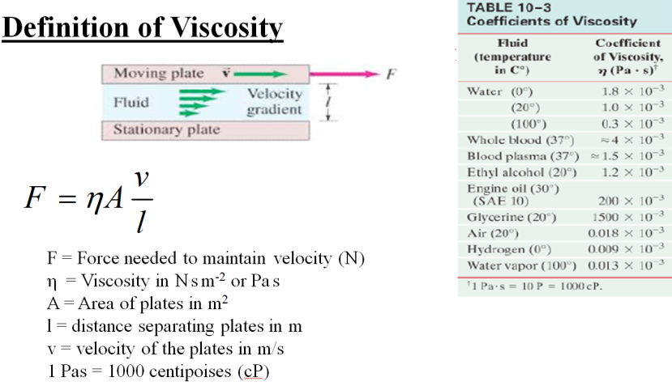

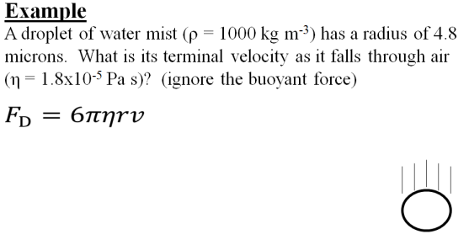
10L
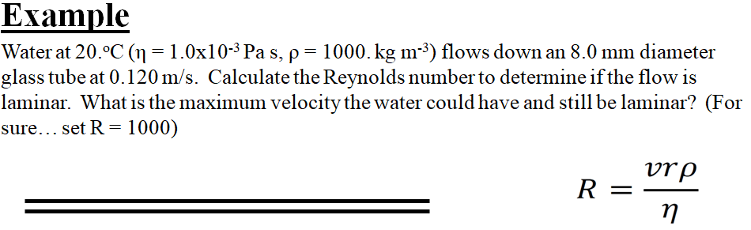
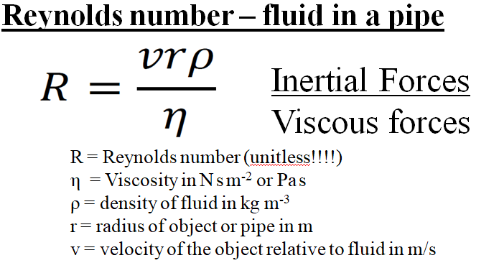
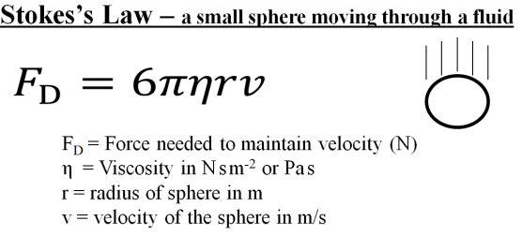
10M

Whiteboards.
1. What force is needed to move a 0.85 cm diameter marble through Karo corn syrup at 1.00 cm/s? η = 2.350 Pa s  (1.9 mN) | 2. A water droplet has a terminal velocity of 0.00350 m/s falling through air. What is its radius? (ignore the buoyant force)  Water: ρ = 1000. kg m⁻³  Air: η = 1.81x10⁻⁵ Pa s  (5.39 microns)
3. What would be the terminal velocity of a 8.20 μm diameter piece of basalt silt (ρ = 2920 kg m⁻³) sinking in water with a density of 1025 kg m⁻³ and a viscosity of 1.72x10⁻³ Pa s. (You can’t ignore the buoyant force on the particle) What time would it take in minutes and seconds to settle in a test tube that is 5.40 cm tall?  (4.04x10⁻⁵ m/s, 22 minutes 17 s – demo centrifuge) | 4. What is the Reynolds number for a ping pong ball going through the air at 5.10 m/s? Use r = 0.0200 m. Is the flow around it laminar? (R<1000)  ρ = 1.29 kg m⁻³  η = 1.81x10⁻⁵ Pa s  (7270 – so no)
5. What is the maximum speed air could move down a 12.2 cm diameter duct and have laminar flow? (R < 1000)
ρ = 1.29 kg m⁻³
η = 1.81x10⁻⁵ Pa s
(0.230 m/s)

