Videos 10H – Buoyancy Name

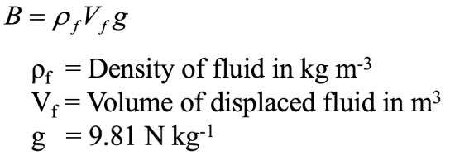

Example – What is the buoyant force on a 3.0 cm diameter air bubble under water? ρH2O = 1.0E3 kg m⁻³

Example - What is the buoyant force on a 5.45 kg iron shot submerged in water? What is the weight of the shot in air, and what is its apparent weight submerged?
ρFe = 7.8E3 kg m⁻³, ρH2O = 1.0E3 kg m⁻³, ρ = m/V so V = m/ρ

Example - The King’s crown has a mass of 14.7 kg, but appears to have a mass of only 13.4 kg when weighed when it is submerged in water. What is the density of the crown? Is it gold?
ρAu = 19.3E3 kg m⁻³, ρH2O = 1.0E3 kg m⁻³, ρ = m/V so V = m/ρ

Over for whiteboards

Whiteboards:
1. What is the buoyant force on a rectangular block of wood that measures 12x23x15 cm if it is submerged in the Dead Sea where the density of the water is 1240 kg m⁻³?  (convert cm to m first)  (50. N) | 2. A 15x15x5.0 cm piece of wood floats in water  (1000. kg m⁻³) face down in the water with the waterline 3.1 cm up the 5.0 cm side:  What is its mass?  What is its density?  (620 kg m⁻³)
3. A 5.0x4.0x4.0 cm piece of wood with a density of 530 kg m⁻³ is tied to the bottom of a pail of water (1000. kg m⁻³) with a string and held completely submerged. What is the tension on the string? (0.37 N) | 4. A 25x25x10 cm block of iron (7.80x10³ kg m⁻³) floats on mercury (13.6x10³ kg m⁻³) If one of the 25x25 cm faces is down into the mercury, how far into the mercury does the block sink before coming to equilibrium? (5.7 cm)

