Videos 10C - Pressure, Force, Area Name
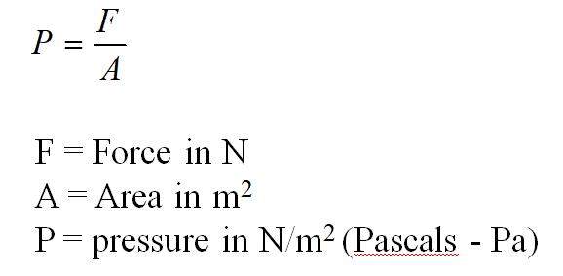

Example - A 2.4 kg box measures 15 cm by 25 cm on the base. What is the pressure under the box?

Whiteboards:
1. What is the pressure of 42 N on a 20. cm x 32 cm plate?  (660 Pa) | 2. What force does 3.200 kPa exert on a 78.0 cm x 182 cm pane of glass?  (4540 N)
3. A hydraulic jack lifts a 31,360 N car using a pressure of 1.38 MPa (M = x 10⁶) What is the diameter of the cylinder?
(0.170 m)

