Videos 10B - Density Name
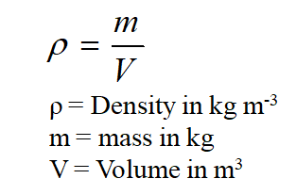

Example – What is the mass of an iron cannon ball that is 17 cm in diameter?

Whiteboards:
1. What is the destiny of a fluid if 2.00 liters of it has a mass of 1.58 kg? (1000 liters = 1 m³) (790 kg m⁻³ ) | 2. What volume (in m3) of mercury has a mass of 1.00 kg?  (ρ = 13.6x10³ kgm⁻³)  How many ml is this? (1 m³ = 10⁶ ml)  (7.4x10⁻⁵ m³, 74 ml)
3. What would be the mass of a gold brick that measures the same as a standard building brick?
(A regular building brick has a mass of about 2 kg)
(92 x 57 x 203 mm, ρ = 19.3x10³ kgm⁻³)

