Videos 10B - Density Name
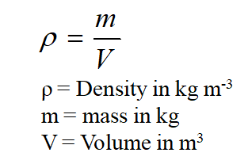

Example – What is the mass of an iron cannon ball that is 17 cm in diameter?

Whiteboards:
1. What is the destiny of a fluid if 2.00 liters of it has a mass of 1.58 kg? (1000 liters = 1 m³) (790 kg m⁻³ ) | 2. What volume (in m3) of mercury has a mass of 1.00 kg?  (ρ = 13.6x10³ kgm⁻³)  How many ml is this? (1 m³ = 10⁶ ml)  (7.4x10⁻⁵ m³, 74 ml)
3. What would be the mass of a gold brick that measures the same as a standard building brick?
(A regular building brick has a mass of about 2 kg)
(92 x 57 x 203 mm, ρ = 19.3x10³ kgm⁻³)

Videos 10C - Pressure, Force, Area Name
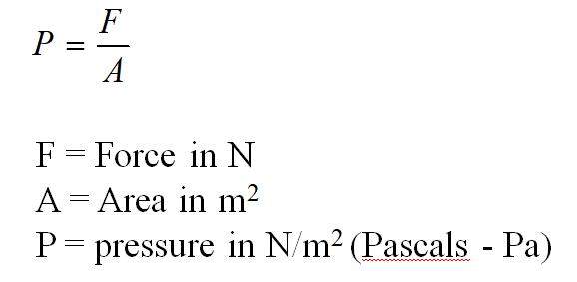

Example - A 2.4 kg box measures 15 cm by 25 cm on the base. What is the pressure under the box?

Whiteboards:
1. What is the pressure of 42 N on a 20. cm x 32 cm plate?  (660 Pa) | 2. What force does 3.200 kPa exert on a 78.0 cm x 182 cm pane of glass?  (4540 N)
3. A hydraulic jack lifts a 31,360 N car using a pressure of 1.38 MPa (M = x 10⁶) What is the diameter of the cylinder?
(0.170 m)

Videos 10D - Pressure Conversions Name
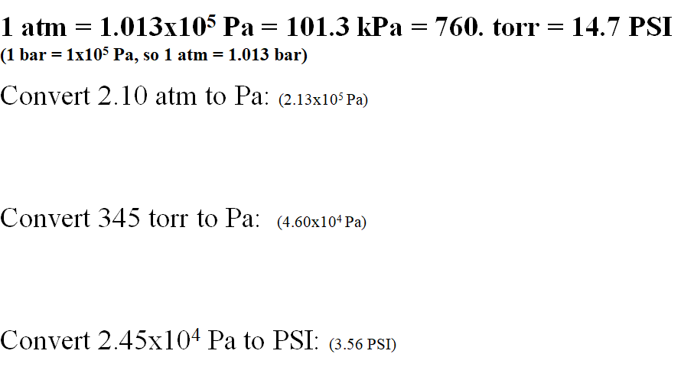

Whiteboards:
1. Convert 32 psi to kPa  (220 kPa) | 2. Convert 890 Torr (mm Hg) to Pa  (1.2x10⁵ Pa )
3. Convert 2000 psi to atm:
(136 atm ≈ 100 atm )

Videos 10E - Gauge Pressure Name
Most pressure gauges compare to Atmospheric
Gauge pressure is how much more a pressure is
than atmospheric
(i.e. this room is at 0 Gauge - Absolute P is 1 atm more)
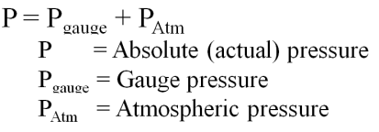
Example 1 – If your tyre pressure gauge reads 220 kPa, what is the actual pressure in the tyre in kPa and Pa?

Example 2 – What is the gauge pressure if you have an actual pressure of 1072 Torr?

Whiteboards: 1 atm = 1.013 x 10⁵ Pa = 101.3 kPa = 760 Torr = 14.7 psi
1. What is the absolute pressure if you read 35 psi gauge? Answer in psi and Pascals  (49.7 psi, 3.42E5 Pa) | 2. If you have an absolute pressure of 812 Torr, what is the gauge pressure? Answer in Torr  (52 Torr )
3. What is the absolute pressure if the gauge pressure is 2.17 x 10⁵ Pa. Answer in Pa  (3.18 x 10⁵ Pa ) | 4. If you have an absolute pressure of 42.0 kPa, what is the gauge pressure in kPa?  (-59.3 kPa)

Videos 10F - Hydrostatic Pressure Name
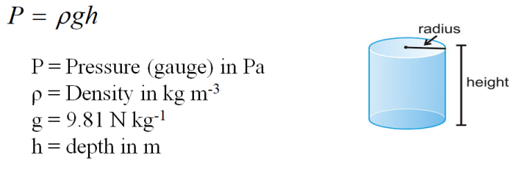

Example – What is the gauge pressure 3800 m (12,500 ft) deep in the ocean where the wreck of the Titanic lies? Calculate it in Pa, PSI and atm. (ρ = 1.025x10³ kg m⁻³)

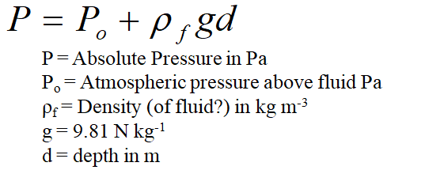
Example – At what depth below fresh water is the absolute pressure 100. PSI? (Po = 1.013x10⁵ Pa, ρ = 1.00x10³ kg m⁻³)

Whiteboards:
1. The water level in a water tower is 30. m above the point where a faucet is. What is the absolute pressure in Pa and PSI? (P_{o} = 1.013x10⁵ Pa, ρ = 1.00x10³ kg m⁻³) What is the gauge pressure in PSI? P = P_{o} + ρgh (4.0E5 Pa, 57 psi, 43 psi) | 2. The density of air at STP is 1.29 kg m⁻³. What is the difference in air pressure between the top and the bottom of the 381 m tall Empire State Building in Pa? (assume the density is constant….) ΔP = ρgh  If the pressure is 1.025x10⁵ Pa at the bottom, what is the pressure at the top?  (4.82E3 Pa, 0.977E5 Pa (9.77E4 Pa))
3. At what depth in mercury is the gauge pressure equal to one atmosphere? (ρ = 13.6x10³ kg m⁻³)
(answer in m and mm)
P = ρgh
1 atm = 1.013 x 10⁵ Pa = 101.3 kPa = 760 Torr = 14.7 psi
(0.759 m, 760 mm)

Videos 10G – Pascal’s Principle Name

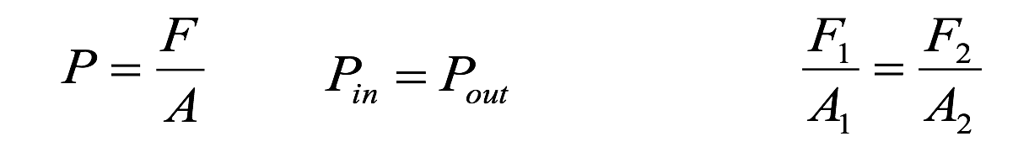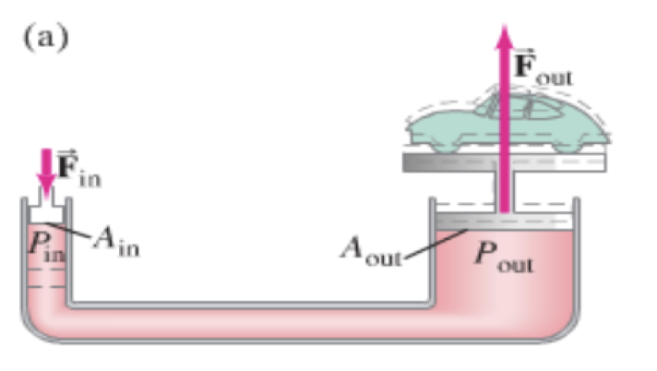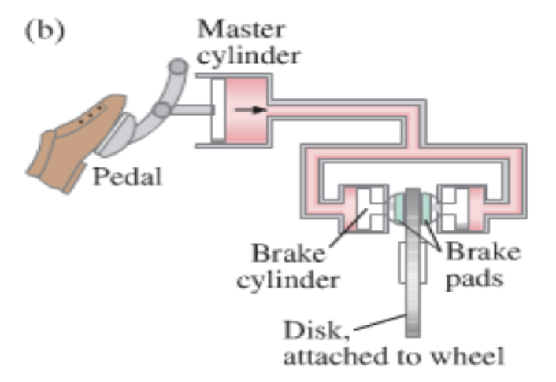

Example – A hydraulic jack has an input piston with a diameter of 8.20 mm, and an output piston diameter of 95.0 mm. What force in Newtons do you need to apply to lift a ton? (8900 N) What is the pressure in Pa? How far must you move the input cylinder to raise the car 10.0 cm?

Whiteboards:
1. A car has a master cylinder bore size of 2.50 cm, and a caliper bore of 4.40 cm. What force does the caliper exert if you press on the master cylinder with a force of 150 N?  (465 N) | 2. A hydraulic jack has an output cylinder with a 5.2 cm bore, and needs to lift a 53,400 N weight with an input force of 356 N. What is the diameter of the input cylinder needed?  (0.0042 m or 0.42 cm)

Videos 10H – Buoyancy Name

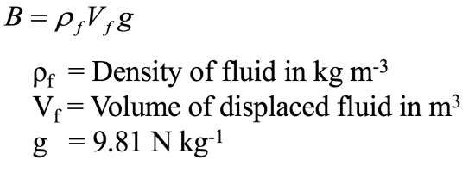

Example – What is the buoyant force on a 3.0 cm diameter air bubble under water? ρH2O = 1.0E3 kg m⁻³

Example - What is the buoyant force on a 5.45 kg iron shot submerged in water? What is the weight of the shot in air, and what is its apparent weight submerged?
ρFe = 7.8E3 kg m⁻³, ρH2O = 1.0E3 kg m⁻³, ρ = m/V so V = m/ρ

Example - The King’s crown has a mass of 14.7 kg, but appears to have a mass of only 13.4 kg when weighed when it is submerged in water. What is the density of the crown? Is it gold?
ρAu = 19.3E3 kg m⁻³, ρH2O = 1.0E3 kg m⁻³, ρ = m/V so V = m/ρ

Over for whiteboards

Whiteboards:
1. What is the buoyant force on a rectangular block of wood that measures 12x23x15 cm if it is submerged in the Dead Sea where the density of the water is 1240 kg m⁻³?  (convert cm to m first)  (50. N) | 2. A 15x15x5.0 cm piece of wood floats in water  (1000. kg m⁻³) face down in the water with the waterline 3.1 cm up the 5.0 cm side:  What is its mass?  What is its density?  (620 kg m⁻³)
3. A 5.0x4.0x4.0 cm piece of wood with a density of 530 kg m⁻³ is tied to the bottom of a pail of water (1000. kg m⁻³) with a string and held completely submerged. What is the tension on the string? (0.37 N) | 4. A 25x25x10 cm block of iron (7.80x10³ kg m⁻³) floats on mercury (13.6x10³ kg m⁻³) If one of the 25x25 cm faces is down into the mercury, how far into the mercury does the block sink before coming to equilibrium? (5.7 cm)

Videos 10I – Continuity Name
Concept 0
Volume flow rate = Av

Example - What is the volume flow rate of air moving at 1.30 m/s down a hallway that measures 3.20 m by 4.10 m? What time will it take to change the air in a room that measures 10.2 m x 14.0 m x 5.20 m?

Concept 1
A₁v₁ = A₂v₂
A = Area (m²)
v = Velocity (m/s)
A 12.0 cm inner diameter pipe with water flowing at 1.18 m/s narrows to 5.00 cm inner diameter. What is the velocity in the narrow part? What is the volume flow rate in m³/s?

Whiteboards:
1. Water is going at 1.45 m/s down a fire hose with a 6.20 cm inner diameter. If the water leaves the hose at a speed of 17.3 m/s, what is the inner diameter of the nozzle? (1.79 cm) | 2. All the air going down a 3.0x4.0 m hallway goes through a doorway that measures 74 cm by 203 cm. If the air in the doorway is going 1.8 m/s, what is the speed of the air in the hallway? (0.23 m/s )
3. A hydraulicking monitor or giant discharges water at 44.0 m/s from a 3.0 cm diameter nozzle. What is the flow rate in m3/s, and what is the velocity in the 12 cm diameter supply pipe?
What recoil force does it exert? (0.031 m³/s, 2.75 m/s, 1400 N, don't worry about the force so much)

Videos 10J – Bernoulli Name

Write down the derivation:
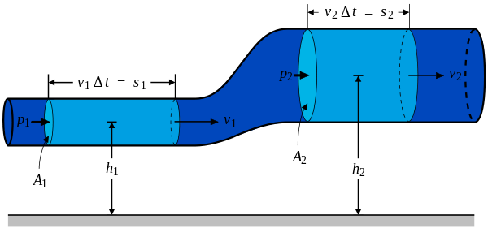

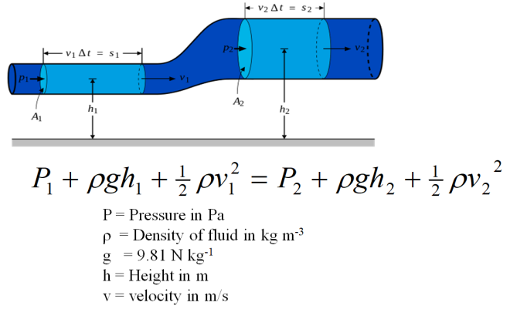 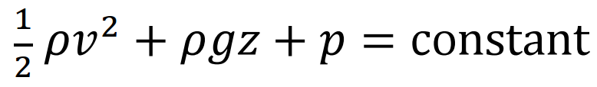(data packet)

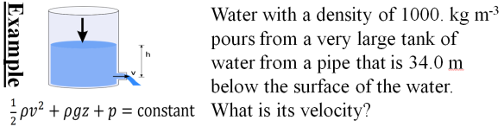

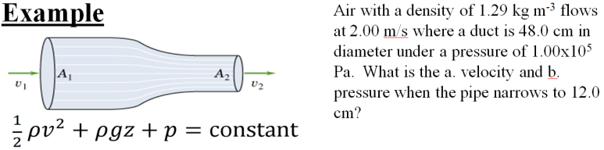

Whiteboards.
1. The wind is moving horizontally at 12.0 m/s over a level rectangular roof that measures 4.50 m by 8.00 m.  A. What is the pressure difference between the bottom (still air) and the top (moving air) of the roof surface? Use 1.29 kg m⁻³ for the density of the air, neglect the change in height, and assume (if you need to) that the pressure underneath is 1.013x10⁵ Pa. B. What is the net upward force on the roof?  (92.9 Pa, 3340 N (751 lbs) ) | 2. A very large Nitrogen tank is at 2000. PSI. If nitrogen at STP has a density of 1.17 kg m⁻³, how fast is the gas going if the valve breaks off when the tank is horizontal  (assume P1 is 2000 PSI (convert), v1 is zero?, P2 is 1.013E5 Pa, solve for v2. Ignore change in height.) 1 atm = 14.7 PSI  (4835.9 or roughly 4840 m/s, 3090 N (695 lbs) )
3. What pressure is needed in a fountain if it is spraying water straight up to a height of 23.2 m? What is the gauge pressure?  ρ = 1000. kg m⁻³, P₂ = 1.013E5 Pa  (3.29x10⁵ Pa, 2.28x10⁵ Pa) | 4. A water faucet breaks in the Physics room, spraying water upwards. If the gauge pressure in the water mains is 21.0 PSI, (at v = 0) with what speed does the water hit the ceiling 4.80 m above the faucet? How much time does it take a custodian to come down and fix the leak?  ρ = 1000. kg m⁻³, P₂ = 1atm = 1.013E5 Pa. 1 atm = 14.7 PSI  (14.0 m/s )
5. Water flows at 2.00 m/s at ground level with a pressure of 1.15x10⁵ Pa through a 10.0 cm diameter pipe. What is the pressure if it is at an elevation of 3.50 m going through a 6.00 cm diameter pipe? (Find the second speed first. ρ = 1000. kg m⁻³)
(6.72x10⁴ Pa )

Videos 10K, L, M – Viscosity, Stokes, and Reynolds Numbers Name

10K
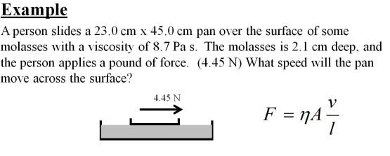
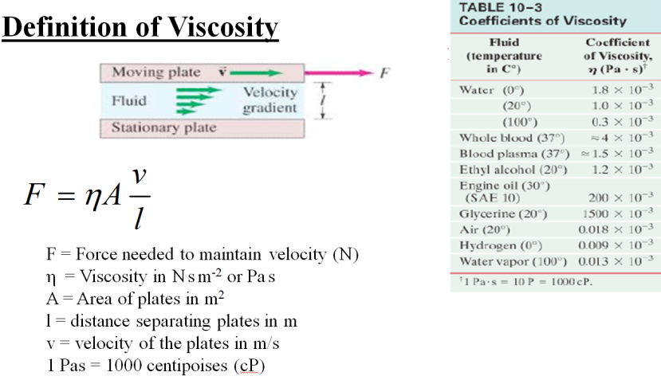

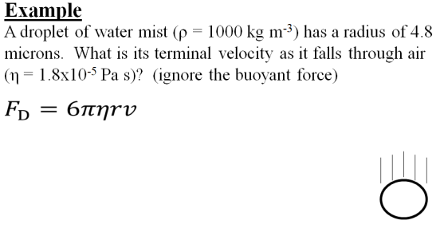
10L
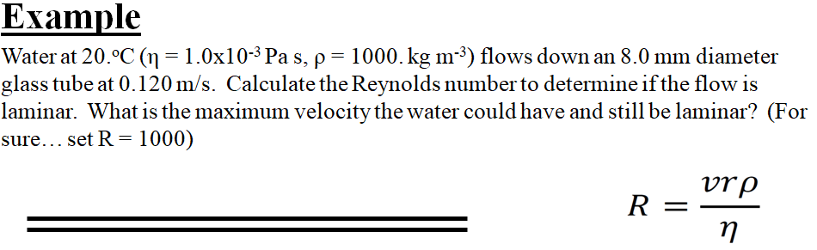
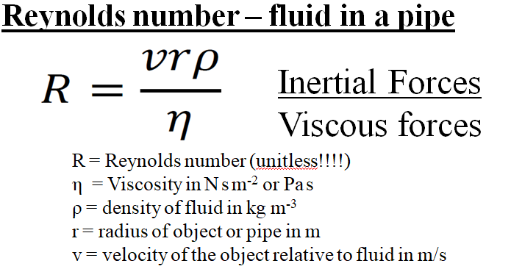
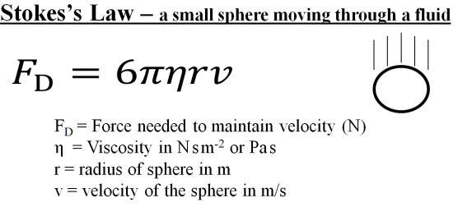
10M

Whiteboards.
1. What force is needed to move a 0.85 cm diameter marble through Karo corn syrup at 1.00 cm/s? η = 2.350 Pa s  (1.9 mN) | 2. A water droplet has a terminal velocity of 0.00350 m/s falling through air. What is its radius? (ignore the buoyant force)  Water: ρ = 1000. kg m⁻³  Air: η = 1.81x10⁻⁵ Pa s  (5.39 microns)
3. What would be the terminal velocity of a 8.20 μm diameter piece of basalt silt (ρ = 2920 kg m⁻³) sinking in water with a density of 1025 kg m⁻³ and a viscosity of 1.72x10⁻³ Pa s. (You can’t ignore the buoyant force on the particle) What time would it take in minutes and seconds to settle in a test tube that is 5.40 cm tall?  (4.04x10⁻⁵ m/s, 22 minutes 17 s – demo centrifuge) | 4. What is the Reynolds number for a ping pong ball going through the air at 5.10 m/s? Use r = 0.0200 m. Is the flow around it laminar? (R<1000)  ρ = 1.29 kg m⁻³  η = 1.81x10⁻⁵ Pa s  (7270 – so no)
5. What is the maximum speed air could move down a 12.2 cm diameter duct and have laminar flow? (R < 1000)
ρ = 1.29 kg m⁻³
η = 1.81x10⁻⁵ Pa s
(0.230 m/s)

