Noteguide for solving Translational and Torsional equilibrium Problems

In general, a system that is in equilibrium is in translational equilibrium and torsional equilibrium:
Force Equilibrium:
  - Draw Picture/Draw Arrows for forces
  - Calculate weights
  - Express/calculate components
  - Set up a <sum of all forces> = 0 equation for x
  - and a <sum of all forces> = 0 for the y direction
Torque Equilibrium:
  - Pick a Pivot Point
(at location of unknown force)
  - Express all torques:
  - ±rF ± rF ± rF… = 0
+ is CW, - is ACW
r is distance from pivot
Do Maths
Typically, the torque equation is solvable, and then you can substitute into the other two equations

Example 1: The beam is 6.0 m long, 45 kg and uniform. The person is standing 0.50 m from the right side, and F₂ is 4.0 m from the left side. Find F1 and F2 (F1 = 125.08 N down, F2 = 1194.4 N up)

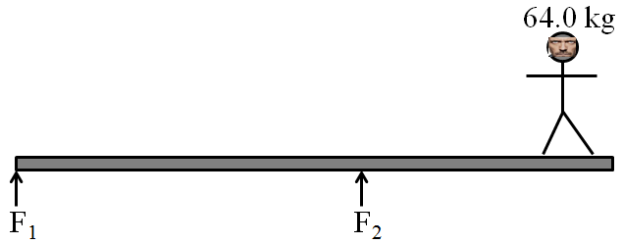

The beam is uniform and 4.00 m long, the cable is attached 2.30 m from the left side at a 30.0º angle with the beam. Find T, Wx, Wy: (T = 375 N, Wx = 325 N right, Wy = 20.9 N down)

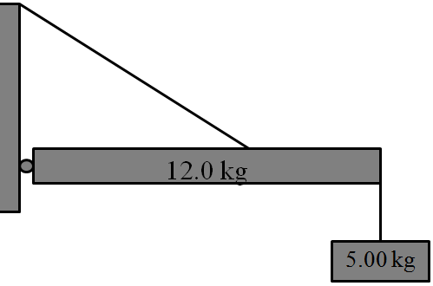

The 10.0 kg beam is uniform and 8.00 m long and makes an angle of 35.0º with the wall, the cable is attached 3.80 m from the bottom end. Find the tension in the cable and the force exerted by the wall in the x and y direction (Careful what angle you use for the tension) T = 274.8 N, Wx = 274.8 N right, Wy = 235.4 N up

