Noteguide for Center of Mass (Videos 9E) Name

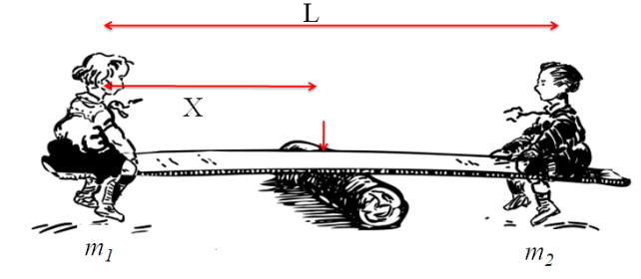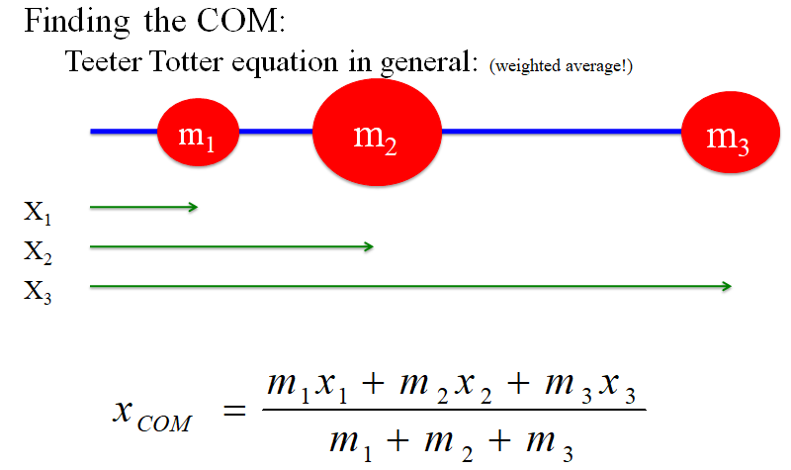

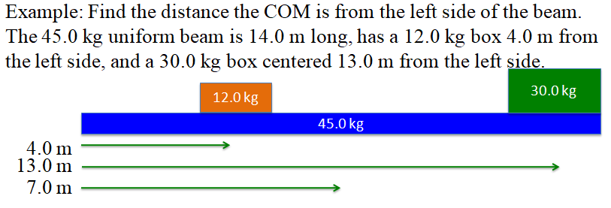

Whiteboards: (Skip #2, unless you don't want to)
1. The center of the 5.00 kg is 34.0 cm from the center of the 2.00 kg. How far from the 5.00 kg center is the COM? (hint: X_{5kg} = 0)  (9.71 cm) | 3. A uniform meter stick has a mass of 85.0 grams, and I place a 15.0 gram clamp at the 24.0 cm mark, and the 55.0 cm mark. At what mark would it balance? (Assume the meter stick to have a COM at 50.0 cm)  (47.3 cm)
4. A uniform meter stick has a mass of 116 grams, and has a 24.0 g mass at the 40.0 cm mark. Where do you clamp a 32.0 g mass to make it balance at the 42.0 cm mark?  (14.5 cm) | 5. A uniform meter stick has a mass of 95.0 grams, and has a 12.0 g mass at the 13.0 cm mark. What mass do you put at the 85.0 cm mark to make it balance at the 56.0 cm mark?  (37.4 g)

