Noteguide for Torsional Equilibrium (Videos 9D) Name
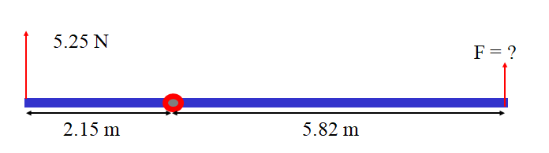
How to set up torque equilibrium:
- Pick a point to torque about.
- Express all torques:
- ±rF ± rF ± rF… = 0
  - + is CW, - is ACW
  - r is distance from pivot
- Do math

Whiteboards:
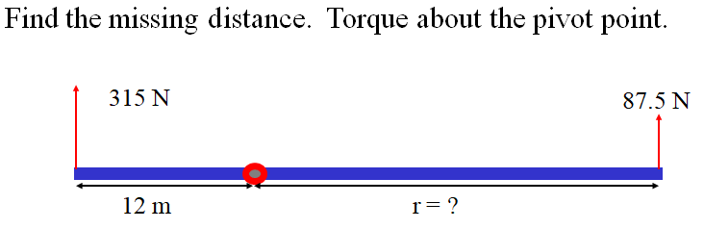 (43 m) | 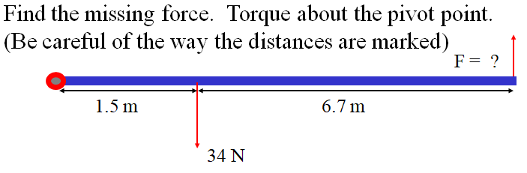 (6.2 N up)
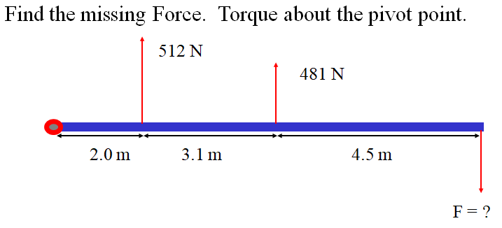 (360 N) | 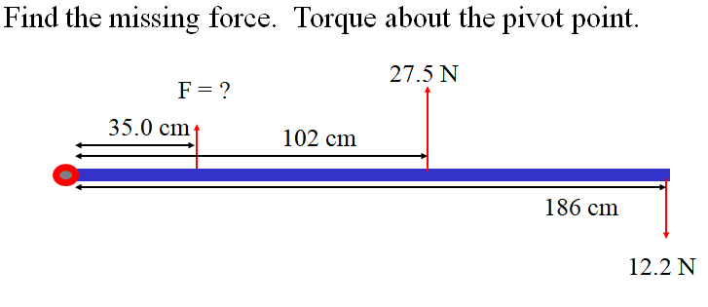  (15.3 N down)

Example: The uniform beam is 6.00 m long. The box is 2.00 m from the left side, the person is 1.00 m from the right side. What does F have to be to support the beam if it is exerted 4.10 m from the left side?
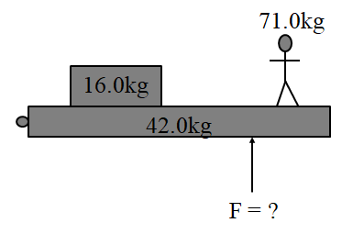

Whiteboards:
The uniform beam is 8.00 m long. The person is 2.10 m from the right side. What distance must the force of 1900 N be exerted from the left side to hold up the beam?  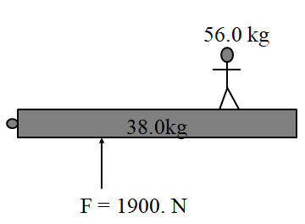(2.49 m from the left side ) | A 7.00 m long uniform beam has a mass of 43.0 kg. A 64.0 kg person is standing 2.00 m from the left side, and a 52.0 kg person is standing 1.00 m from the right side. What is the tension in the cable on the right side? Pretend that the beam is all at its middle. (3.50 m from the side)  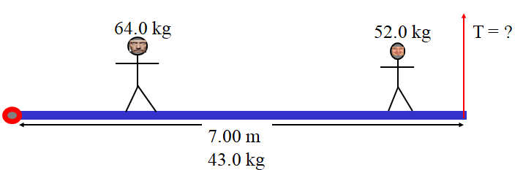(828 N)
The 14.0 kg beam is uniform and 4.20 m long. The 11.0 kg beam is 3.30 m long, and the 18.0 kg box is 1.20 m wide. How far from the left side must the 263 N supporting force be exerted?  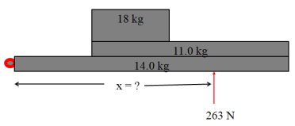 (3.15 m) | 72.0 kg Dad sits 1.20 m from the center of the seesaw, and Keenan sits 3.40 m from the center to balance. What is Keenan’s mass?  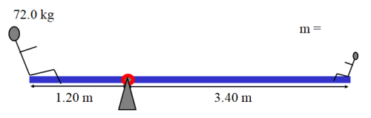 (25.4 kg)

