Noteguide for Translational Equilibrium with Two Unknowns (Videos 9C) Name

- Draw Picture with forces as arrows
- Calculate weights (?)
- Express/calculate components (SOH CAH TOA)
- Set up a <sum of all forces> = 0 equation for x and another for the y direction
- Do math.

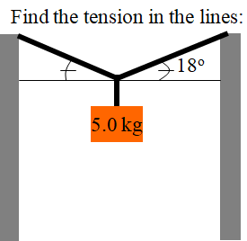

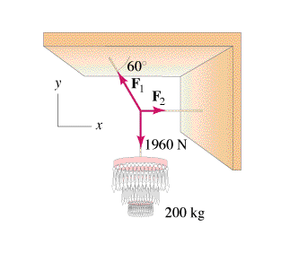

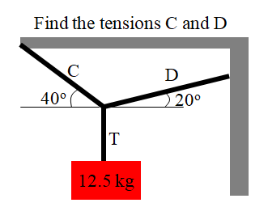

Whiteboards:
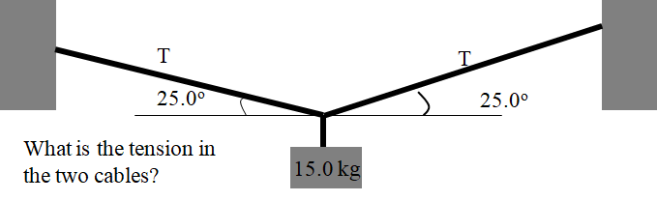 (174 N)

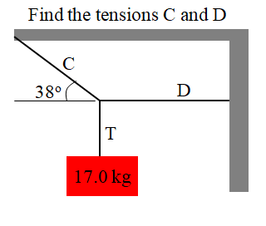(C = 271 N, D = 213 N)

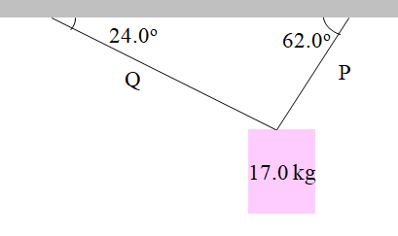(P = 152.7 N, Q = 78.5 N)

