Noteguide for Equilibrant (Videos 9B) Name

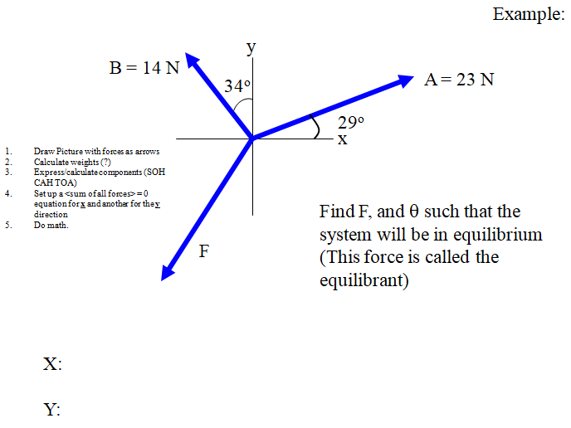

Whiteboard:
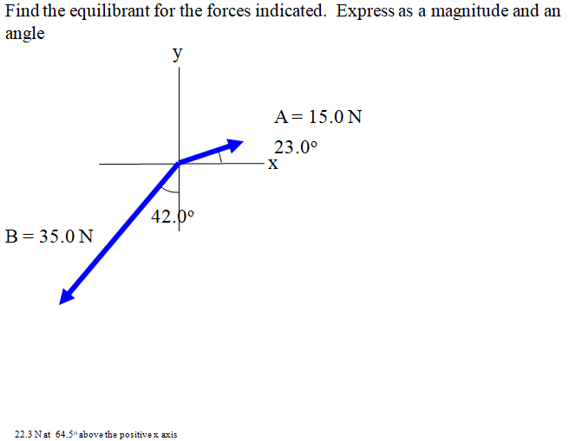

X:

Y:

