Noteguide for Equilibrium (Video 9A) Name

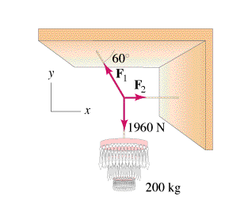

How to solve:
Net force in the x dir. = 0
Net force in the y dir. = 0

Step By Step:
  - Draw Picture with forces as arrows
  - Calculate weights (?)
  - Express/calculate components (SOH CAH TOA)
  - Set up a <sum of all forces> = 0 equation for x and another for the y direction
  - Do math.

