IB Physics
Chapter 9 Syllabus
Statics

A/B | In Class: | Due on this class:
1  Feb 26/27 | DI-Demos  GW-P9.1 #1, 2, 4, 5, 6, 7 | VF 9A, 9B, 9C
2  Feb 28  /Mar 2 | GW-P9.2 #21-28  GW-Force Table lab | VF 9D  Turn in: Force Table Lab
3  Mar  3/4 | SA9.1-Translational Equilibrium (first 30 minutes)  VF-9E Center of Mass  DI-Center Of Mass Demos | Turn in: FA 9.1
4  Mar  5/6 | DI-More Center Of Mass Demos  Group Quiz 9.2  IW-P9.2 #7-10, 14, 15, 16 | VF 9E
5  Mar  9/10 | DI-Demos  Group Quiz 9.3  IW-P9.3 #1-4, 7, 8, 11, 12 | VF 9F
6  Mar  11/12 | SA9.2-Torsional Equilibrium  SA9.3-Trans and Tors (first 60 minutes)  VF-Cat videos | Turn in: FA9.2, FA9.3
7  Mar  13/16 | GW-Center of Mass lab | Turn in: Center of Mass Lab
Mar  17/18 | Vaves! Ja! | VF 11A

2 Labs:  - Force Table Lab  - Center of Mass  3 Formative/Summative Assessments  - 9.1 - Translational Equilibrium  - 9.2 - Torsional Equilibrium and Center of Mass  - 9.3 - Torsional and Translational Equilibrium | Handouts:  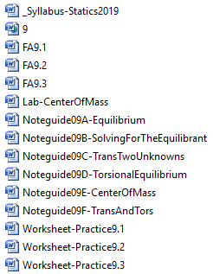

Noteguide for Equilibrium (Video 9A) Name

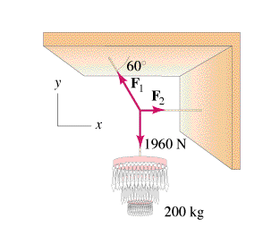

How to solve:
Net force in the x dir. = 0
Net force in the y dir. = 0

Step By Step:
  - Draw Picture with forces as arrows
  - Calculate weights (?)
  - Express/calculate components (SOH CAH TOA)
  - Set up a <sum of all forces> = 0 equation for x and another for the y direction
  - Do math.

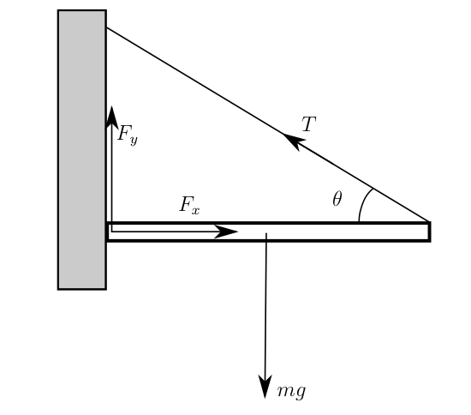

Noteguide for Equilibrant (Videos 9B) Name

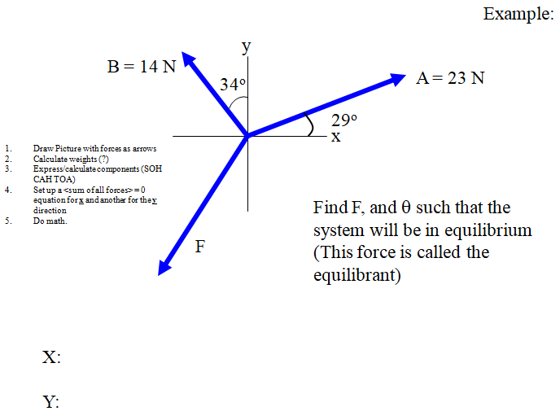

Whiteboard:
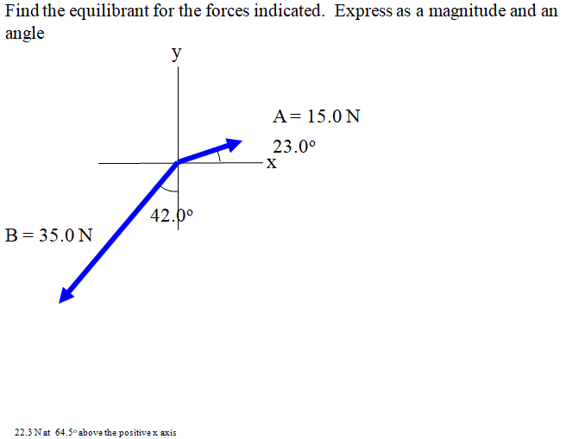

X:

Y:

Noteguide for Translational Equilibrium with Two Unknowns (Videos 9C) Name

- Draw Picture with forces as arrows
- Calculate weights (?)
- Express/calculate components (SOH CAH TOA)
- Set up a <sum of all forces> = 0 equation for x and another for the y direction
- Do math.

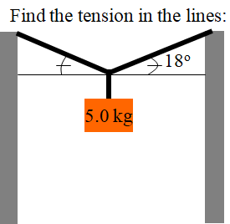

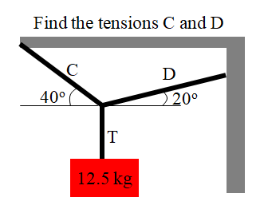

Whiteboards:
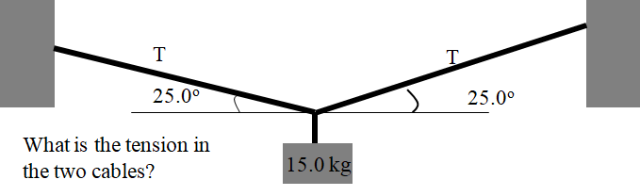 (174 N)

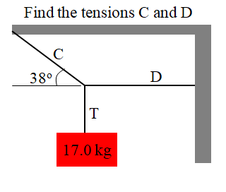(C = 271 N, D = 213 N)

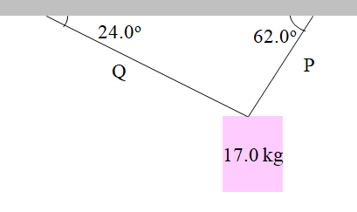(P = 152.7 N, Q = 78.5 N)

Translational Equilibrium 9.1
1. | Find the third force (the equilibrant) that would prevent the system from accelerating. 23.16 N At 292.8º Trig angle. (22.8º to the right of the -y axis)
2. | Find the third force (the equilibrant) that would prevent the system from accelerating. 6.000 N At 348.9º Trig angle. (11.1º below the +x axis)
3.  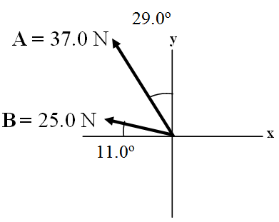 | Find the third force (the equilibrant) that would prevent the system from accelerating. 56.4 N @ 318.8º Trig angle. (41.2º below the +x axis)
4. | Cable A makes an angle of 63.0º with the horizontal, and B makes an angle of 23.0º with the horizontal. What is the tension in each cable for there to be no acceleration of the system?  A = 606 N  B = 299 N
5. 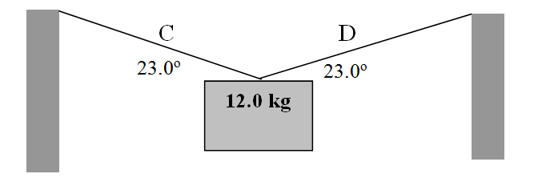 | Find the tensions in Cable C and D:  C = 151 N  D = 151 N

6.  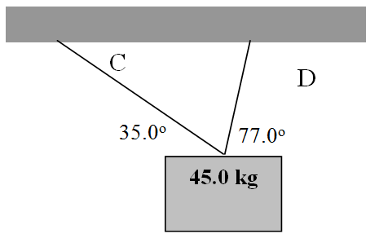 | Find the tensions in Cable C and D:  C = 107 N  D = 390. N
7.  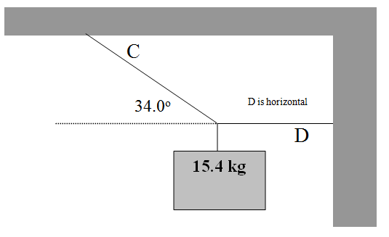 | Find the tensions in Cable C and D:  C = 270. N  D = 224 N
8.  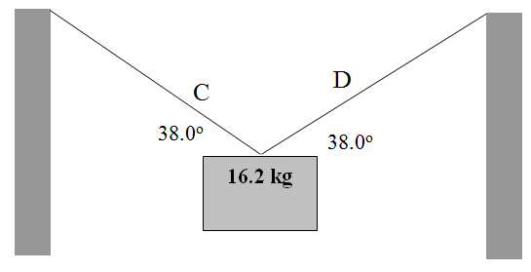 | Find the tensions in Cable C and D:  C = 129 N  D = 129 N
9.  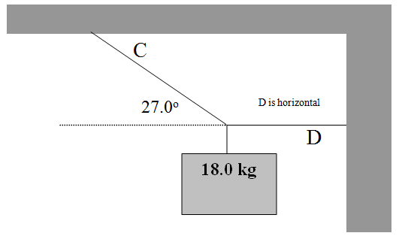 | Find the tensions in Cable C and D:  C = 389 N  D = 347 N
10. | Cable A has a force of 23 N along it, what must be the tensions in cable C and B for there to be no acceleration of the system?  B = 17 N  C = 27 N
Also from your textbook: Chapter 9: 1, 5, 9, 11, 12, 14 starting p. 247

Noteguide for Torsional Equilibrium (Videos 9D) Name
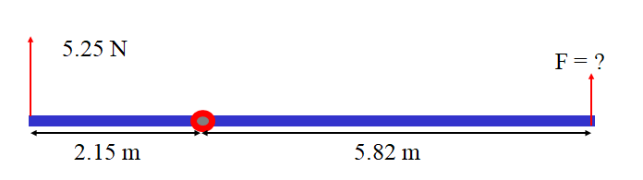
How to set up torque equilibrium:
- Pick a point to torque about.
- Express all torques:
- ±rF ± rF ± rF… = 0
  - + is CW, - is ACW
  - r is distance from pivot
- Do math

Whiteboards:
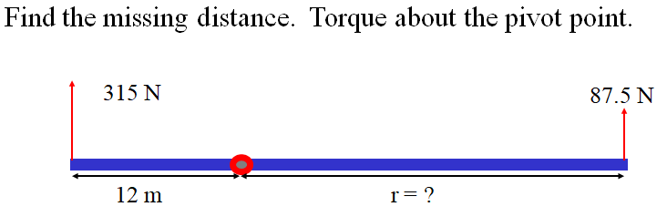 (43 m) | 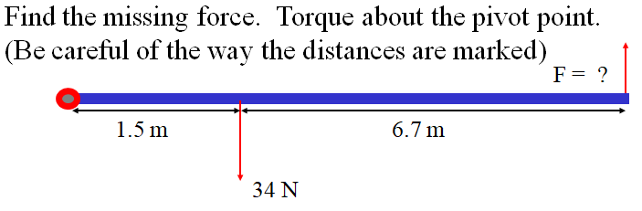 (6.2 N up)
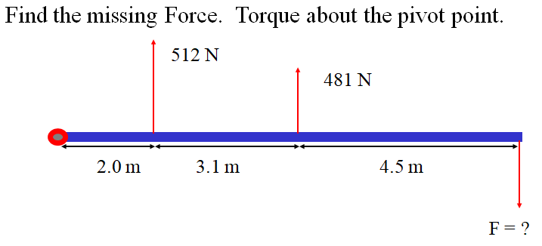 (360 N) | 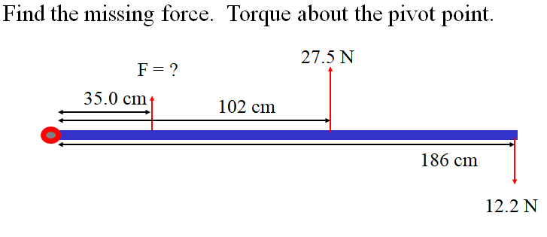  (15.3 N down)

Example: The uniform beam is 6.00 m long. The box is 2.00 m from the left side, the person is 1.00 m from the right side. What does F have to be to support the beam if it is exerted 4.10 m from the left side?
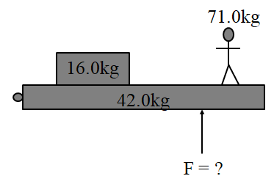

Whiteboards:
The uniform beam is 8.00 m long. The person is 2.10 m from the right side. What distance must the force of 1900 N be exerted from the left side to hold up the beam?  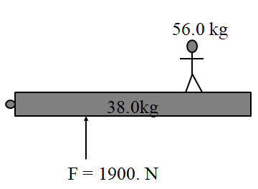(2.49 m from the left side ) | A 7.00 m long uniform beam has a mass of 43.0 kg. A 64.0 kg person is standing 2.00 m from the left side, and a 52.0 kg person is standing 1.00 m from the right side. What is the tension in the cable on the right side? Pretend that the beam is all at its middle. (3.50 m from the side)  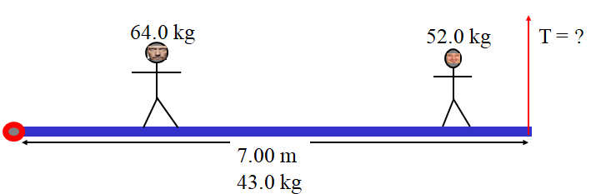(828 N)
The 14.0 kg beam is uniform and 4.20 m long. The 11.0 kg beam is 3.30 m long, and the 18.0 kg box is 1.20 m wide. How far from the left side must the 263 N supporting force be exerted?  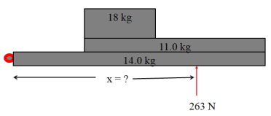 (3.15 m) | 72.0 kg Dad sits 1.20 m from the center of the seesaw, and Keenan sits 3.40 m from the center to balance. What is Keenan’s mass?  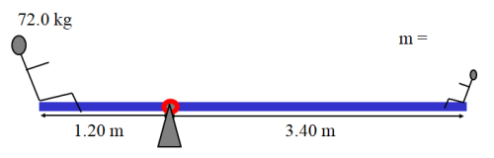 (25.4 kg)

Noteguide for Center of Mass (Videos 9E) Name

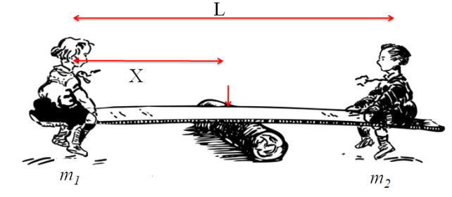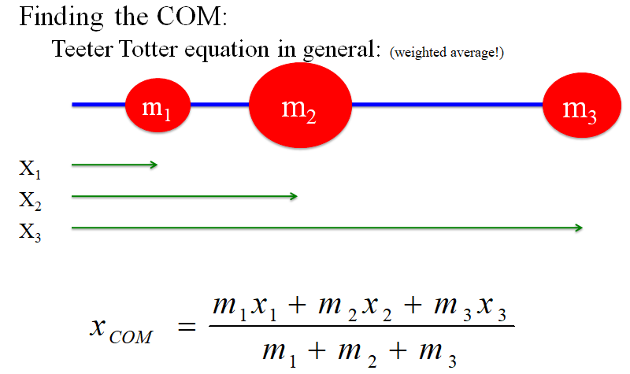

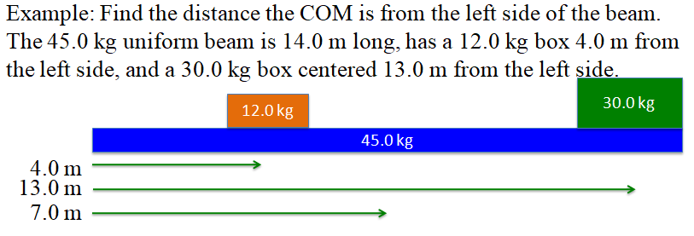

Whiteboards: (Skip #2, unless you don't want to)
1. The center of the 5.00 kg is 34.0 cm from the center of the 2.00 kg. How far from the 5.00 kg center is the COM? (hint: X_{5kg} = 0)  (9.71 cm) | 3. A uniform meter stick has a mass of 85.0 grams, and I place a 15.0 gram clamp at the 24.0 cm mark, and the 55.0 cm mark. At what mark would it balance? (Assume the meter stick to have a COM at 50.0 cm)  (47.3 cm)
4. A uniform meter stick has a mass of 116 grams, and has a 24.0 g mass at the 40.0 cm mark. Where do you clamp a 32.0 g mass to make it balance at the 42.0 cm mark?  (14.5 cm) | 5. A uniform meter stick has a mass of 95.0 grams, and has a 12.0 g mass at the 13.0 cm mark. What mass do you put at the 85.0 cm mark to make it balance at the 56.0 cm mark?  (37.4 g)

Center Of Mass - 9.2
 | Teeter Totter Equation:
0.73 Kg | 1. The center of mass between two objects is 12 cm from the one with a mass of 3.4 Kg. What is the mass of the other one if it is 56 cm from the COM?
1.02 x1032 Kg | 2.A star is seen rotating about a point that is 4.2 x 109 m from its center. We can tell by its light output that it has a mass of 7.5 x 1031. What is the mass of the black hole in orbit around the star if it is 3.1 x 109 m from the COM?
 | The COM Equation
22.7 cm | 3. How far is the COM from the larger of a 12 lb bowling ball and a 10 lb bowling ball that are 50 cm distant?
37.5 cm | 4. A 5 Kg mass is on the 0 end of a meter stick, and a 3 Kg mass is on the 100 and of the stick. Where is the COM? (Neglect the mass of the meter stick)
18.5 feet | 5. A 165 lb and 120 lb person sit on a see saw that is 32 feet long. How far is the balance point from the lighter person?
4.49x102 km | 6. How far is the center of mass of the sun and Earth from the center of the sun? (The Earth-Sun distance is 1.50x10¹¹ m - the sun has a mass of 1.99 x 1030 Kg, and Earth has a mass of 5.97 x 1024 Kg.)
At the 36.3 cm mark | 7. Someone clamps a 50 gram mass to the 15 cm mark of a 78 gram meter stick. Where is the center of mass of the meter stick and mass? (Treat the meter stick as a 78 gram mass at the 50 cm mark)  More than two objects:
At the 45.2 cm mark | 8. Someone puts a 45 gram clamp at the 12 cm mark and a 75 gram clamp at the 60 cm mark of a 82 gram meter stick. Where is the COM of the system now? (don't forget the meter stick itself)
91.7 cm mark | 9. A 112 g uniform meter stick has a 14.0 g clamp at the 40.0 cm mark. Where would you clamp a 21.0 g clamp to make it balance at the 55.0 cm mark?
36.9 g | 10. A 108 g uniform meter stick balances at the 44.0 cm mark when there is a 13.0 g clamp at the 85.0 cm mark and a what mass clamped at the 12.0 cm mark?
7.98 x 105 m | 11. How far is the COM of the four inner planets and the sun from the center of the sun? (If they all lined up
7.98 x 105 m | 11. How far is the COM of the four inner planets and the sun from the center of the sun? (If they all lined up)
66 feet from the ground | 12. Where is the COM of a 120 foot, 495 lb ladder with a 220 lb fireman 12 feet up, a 170 lb fireman 50 feet up and a 150 lb fireman all the way at the top? (The COM of the ladder is 80 feet from the ground)
8.4 feet from the stern | 13. Where is the COM of a loaded 89 lb 18 foot canoe when there is a 160 lb person 1.5 feet from the stern, a 90 lb pack 9 feet from the stern, and a 140 lb bow person 15.5 feet from the stern? (Consider the canoe to be symmetric)
55.6 cm mark | 14. Where is the COM of a 121 g uniform meter stick if there is a 12.0 g clamp at the 7.00 cm mark, a 34.0 g at the 23.0 cm mark and a 56.0 gram clamp at the 98.0 cm mark?
9.80 cm mark | 15. A 68.0 g uniform meter stick has a 15.0 g clamp on the 17.0 cm mark, and it balances at the 32.0 cm mark. Where do you need to clamp a 45.0 g clamp to effect this?
137 g | 16. A 145 g meter stick balances at the 66.6 cm mark. There is a 12.0 g clamp on the 92.0 cm mark, and what mass clamped at the 82.0 cm mark?
 | 17. (Extra credit) Devise a way to construct the center of mass of any triangle using a straight edge, and a compass. Explain this method. (Cut out your triangle from cardboard, and see if it balances on that point you've found. If it doesn't...try again)

Torsional Equilibrium - 9.2
Find the missing quantity to put the system in torsional equilibrium around the pivot point:
1.20 m
1.60 m
14.0 N
7.20 N
1.90 m
F = ?
21. (1.77 N upward) | 22. (8.17 N downward)  6.00 m  13.0 m  118 N  135 N  11.0 m  F = ?
23. (19.6 cm)  13.0 cm  x = ?  7.40 N  1.60 N  41.0 cm  1.20 N | 24. (60.0 cm - note where the distance is measured.)  35.0 cm  x = ?  6.00 N  7.20 N  45.0 cm  1.20 N
25. The 56.0 kg beam is 12.0 m long, the 16.0 kg box is 5.00 m long. The 24.0 kg box is 3.20 m wide, and the supporting force is exerted 4.00 m from the left side. (1534 N)  56.0 kg  16.0 kg  F = ?  24.0 kg | 26. The 62.0 kg window washing scaffold is 9.00 m long, the big 85.0 kg worker is 3.80 m from the left side, and the 64.0 kg worker is 2.50 m from the right. Find the tension in the right cable. (pivot about the left cable) (1110 N)  62.0 kg  F = ?
27. The 24.0 kg diving board is 5.10 m long, but its center of mass is 2.30 m from the left side. A 45.0 kg diver is 2.00 m from the left side, and a 57.0 kg diver is 0.500 m from the right side. How far from the pivot on the left side must the support be placed if the force on it cannot exceed 2150 N? (1.86 m)  24.0 kg  2150 N | 28. The stoplights each have a mass of 28.0 kg, with one hanging 1.80 m from the left side, and the other hanging 0.700 m from the right side. The supporting beam is uniform, 6.20 m long with a mass of 16.0 kg. How far from the left side must the supporting cable be attached if the tension is not to exceed 623 N? (4.00 m)  16.0 kg  623 N

Noteguide for Trans. and Tors. (Videos 9F) Name
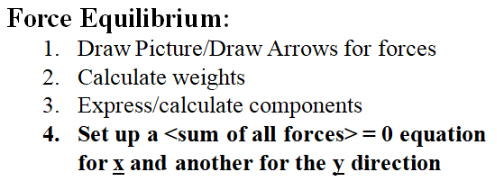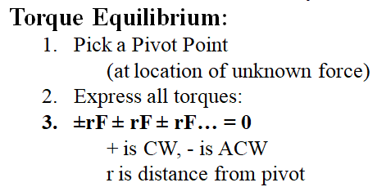

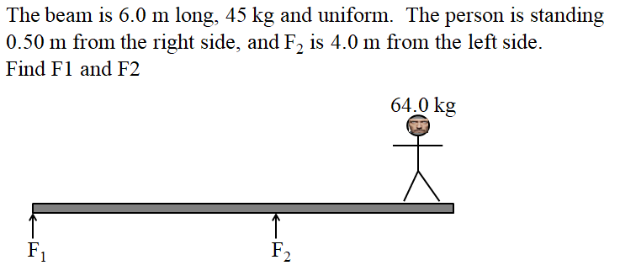

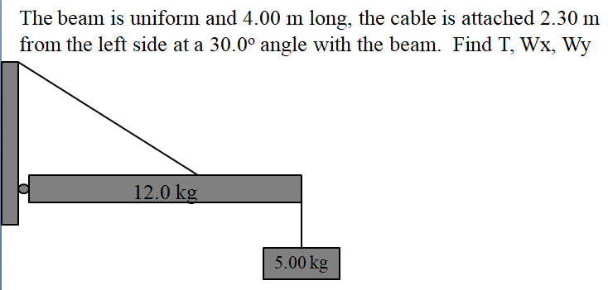

Find T, Wx, Wy:
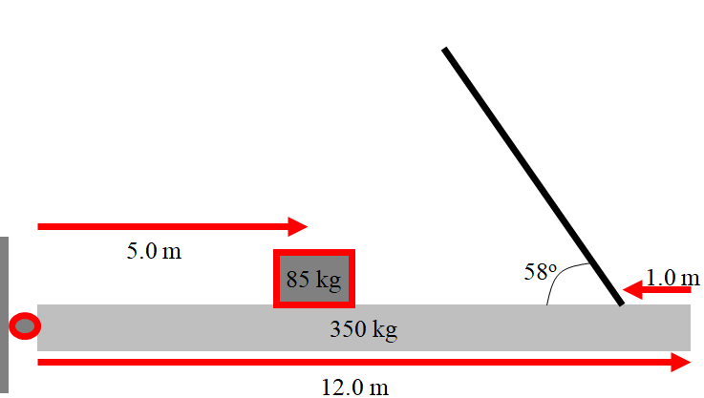
Translational (Y only) and Torsional Equilibrium from 9.3
All beams and objects are uniform.
1. The beam is 6.10 m long, and the person is standing 1.10 m from the right side. Find the tensions in the cables.  (T₁ = 402 N up, T₂ = 854 N up) | 2. The beam is 11.0 m long, and the person is standing 4.00 m from the left side. Find the forces exerted by the supports.  (F₁ = 482 N up, F₂ = 313 N up)
3. The beam is 8.20 m long, and F₂ is 3.00 m from the left side, and the person is 0.500 m from the right side. Find the forces exerted by the supports.  (F₁ = 1030 N down, F₂ = 1830 N up) | 4. The beam is 9.00 m long, and F₂ is 3.00 m from the right side, and the person is 3.00 m from the left side. Find the forces exerted by the supports.  (F₁ = 258 N up, F₂ = 331 N up)
5. The beam is 12.0 m long, the second cable is attached 7.00 m from the left side, and the person is standing 4.00 m from the right side. Find the tensions in the cables.  (F₁ = 56.1 N up, F₂ = 1750 N up) | 6. The 56.0 kg beam is 12.0 m long, the 16.0 kg box is 5.00 m long. The 45.0 kg box is 3.20 m wide. Find F₁ and F₂.  (F₁ = 458 N up, F₂ = 690. N up)  56.0 kg  16.0 kg  F₂ = ?  45.0 kg  F₁ = ?

Translational and Torsional Equilibrium
All beams and objects are uniform.
7. The cable is connected 6.00 m from the left side of, and makes an angle of 39.0º with the 10.0 m long beam. Find the tension in the cable, and the horizontal and vertical components of the force exerted by the wall. Be sure to give the direction of the components.  (T = 351 N, Wx = 273 N right, Wy = 34.3 N down) | 8. The cable makes an angle of 25.0º with the 16.0 m long beam. The sign hangs 5.20 m from the left side of the beam. Find the tension in the cable, and the horizontal and vertical components of the force exerted by the wall. Be sure to give the direction of the components.  (T = 346 N, Wx = 314 N right, Wy = 177 N up)
9. The horizontal cable is connected 4.70 m from the hinge, and makes an angle of 54.0º with the 5.00 m long, 5.30 kg beam. The sign hangs 3.00 m from the hinge. Find the tension in the cable, and the horizontal and vertical components of the force exerted by the wall. Be sure to give the direction of the components.  (T = 38.3 N, Wx = 38.3 N right, Wy = 91.2 N up) | 10. The cable is connected 10.0 m from the hinge, and makes an angle of 60.0º with the 12.0 m long, 8.00 kg beam. The sign hangs 3.10 m from the hinge. Find the tension in the vertical cable, and the horizontal and vertical components of the force exerted by the wall. Be sure to give the direction of the components.  (T = 62.3 N, Wx = 0, Wy = 65.2 N up)
11. The cable is connected 1.50 m from the left side, and makes an angle of 48.0º with the 2.00 m long beam. Find the tension in the cable, and the horizontal and vertical components of the force exerted by the wall. Be sure to give the direction of the components.  (T = 114 N, Wx = 76.6 N left, Wy = 13.1N up) | 12. The rod is connected 3.20 m from the left side of, and makes an angle of 38.0º with the 4.00 m long beam. The box is centered 1.20 m from the left side. Find the force along the rod, and the horizontal and vertical components of the force exerted by the wall. Be sure to give the direction of the components.  (F = 57.8 N, Wx = 45.5 N left, Wy = 33.1 N up)

IB Physics
Center O' Mass

Here you get to try four different ways to find the center o' mass of a two-dimensional rectangular solid. Then you will break through new frontiers trying to find the center of mass of an irregular four-sided figure using geometric methods. This lab is unique in that you will do your very own.

Here's what to do:
1. Get a rectangular piece of heavy paper, and cut out a rectangular chunk from the corner. There are only two rules, the dimensions of the rectangle that you cut out should be between 1/3 and 1/2 the dimensions of the piece, and all the angles formed when you cut it out must be 90o. (Right angles, that is)
2. Find the center of mass by trial and error. (This is an empirical method) The piece will balance on the bottom of a whiteboard marker when the center of mass is directly above it. (Trace around where the center of mass must be) •How does the area of the point on which you are balancing the object affect the precision with which you can locate the center of mass in this way?
3. Punch one hole near one corner, and another near a different corner. Find the center of mass using a chalked plumb line by using the fact that it is always directly beneath the point of suspension. How does this point agree with the one you have already marked? (This too is an empirical method)
4. •Find the center of mass geometrically using the method I showed you on the blackboard. (by subdividing the solid into two rectangles whose COMs you know - and using Murray's Theorem) (This is a geometric method)
5. Pick one of the subdivisions you made in the previous step and use the center of mass equation to find the C.O.M. but instead of M1 and M2, use the areas of the rectangles. (You will have to measure the distance from the center of one rectangle to the center of the other, and then also the lengths of the sides of the rectangles. Area = LxW) (This is an analytic method) •Show this calculation on the heavy paper itself, and measure and mark that distance from the center you calculated.
6. Put a paper clip on the edge of the solid somewhere, and find its center of mass again using an empirical method. •Did the center of mass shift toward or away from the clip?
7. Make a small four-sided figure perhaps from the piece you cut out, with no angle congruent or 90o, and no side parallel. Locate its center using an empirical method of your own choosing and mark it with ink.
(Extra Credit) Drawing lightly in pencil so you can erase it, try to devise a geometric way to locate the center of your solid from number 7. When you think you have it, try it on another solid with different angles. You can use a straight edge and a compass.

Turn in for credit:

- The answers to the questions in parts 2 and 6
- The calculations you made from part 5 - written on the solid itself.
- Your rectangular solid from parts 1-6
- Your four-sided figure from part 7
- (Extra credit 10 pts) Your explanation for part 7

