IB Physics
9F Group Quiz
Name
Set up your torque and x and y translational equilibrium expressions where indicated.
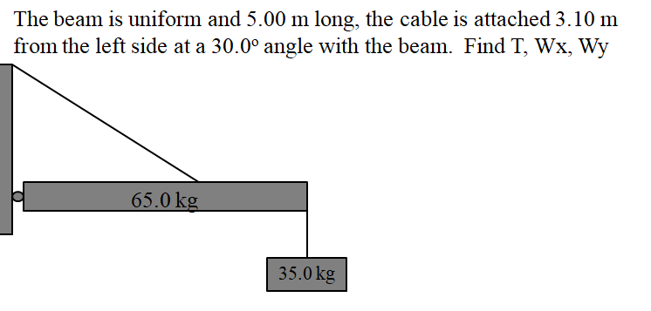
T =

Wx =

Wy =

Γ:

Y:

X:

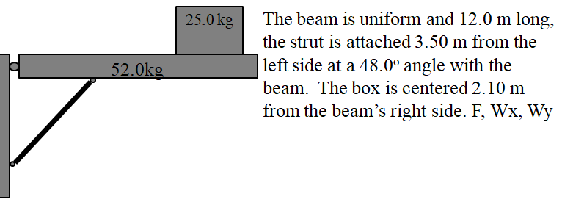
F =

Wx =

Wy =

Γ:

Y:

X:

