Angular Dynamics Noteguide

Angular Quantities:
Linear:  (m) s  (m/s) u  (m/s) v  (m/s/s) a  (s) t  (N) F  (kg) m | Angular:  θ - Angle (Radians)  ω_{i} - Initial angular velocity (Rad/s)  ω _{f} - Final angular velocity (Rad/s)  α - Angular acceleration (Rad/s/s)  t - Uh, time (s)  Γ - Torque (mN)  I - Moment of Inertia (kg m²)

Angular Kinematics:
Linear:  u + at = v  ut + ¹/₂at² = s  u² + 2as = v²  (u + v)t/2 = s  ma = F | Angular:  ω_{f} = ω_{i} + αt  θ = ω_{i}t + ¹/₂αt²  ω_{f} ² = ω_{i}² + 2αθ  θ = (ω_{i} + ω_{f})t/2  Γ = Iα

Torque - twisting force that can cause angular acceleration
Γ = rxF = rFsin(θ)
Γ - Torque (mN)
r - radius (m)
F - force (N)

Example:
If r = 0.50 m, and F = 80 N
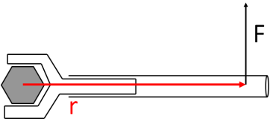

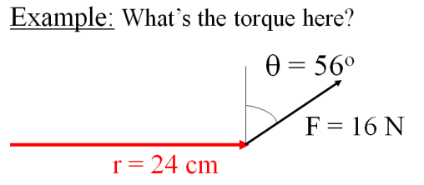

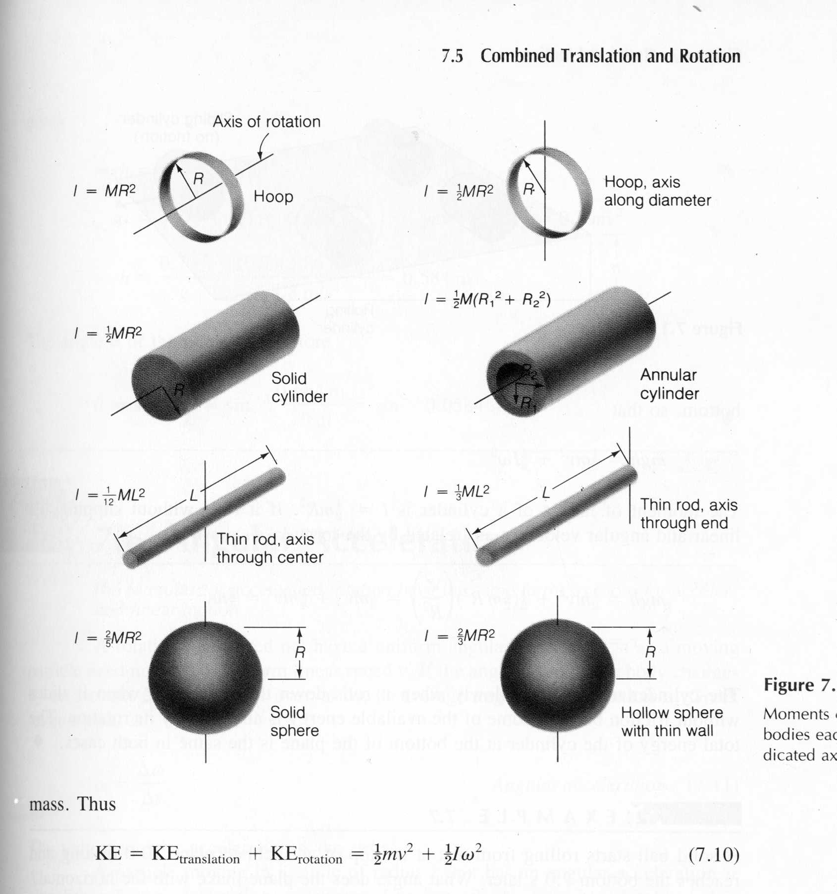
Moment of Inertia:
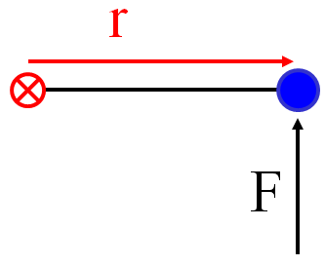
F = ma
Γ = Iα

Example: Three 40. kg children are sitting 1.2 m from the center of a merry-go-round that is a uniform cylinder with a mass of 240 kg and a radius of 1.5 m. What is its total moment of inertia?

Example: A string with a tension of 2.1 N is wrapped around a 5.2 kg uniform cylinder with a radius of 12 cm. What is the angular acceleration of the cylinder? How many rotations will it make before it reaches a speed of 2300 RPM from rest?
1. Find torque: 2. Find I:

3. Find α: 3. Solve suvat:

