Noteguide for Vector Cross Product and Precession (Videos 8Q) Name

Vector Cross Product:

AxB = ABsin(θ) in the right hand direction

The Right Hand Direction is Funky:

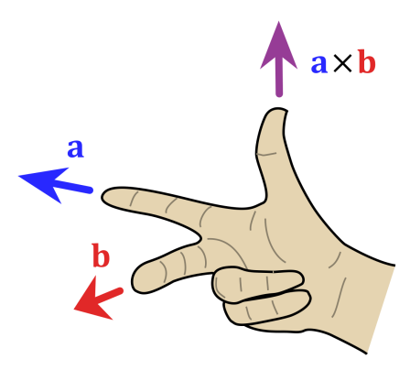
Using your Right hand:
Index Finger: First vector (a in this case)
Middle Finger Second Vector (b in this case)
Thumb: Direction of the cross product

Note that cross products are NOT commutative. (AxB = -BxA)

Whiteboards: (. is out of the page, and x is into the page. The x in the middle just means cross product)
X
X
X
X

x
.
.

Out of the page | Up the page | Left | Right

So Gyroscopes precess because of torque:

Γ = rxF

A wheel spinning anti clockwise has an angular velocity and momentum that is represented by a vector pointing straight at you. (This is another right hand rule that I will explain in class) The tip of that angular momentum vector will go in the direction of rxF using the right hand rule above.

Watch the Ve video and we will do some examples in class.

