Noteguide for Rotational Kinetic Energy (Videos 8K) Name

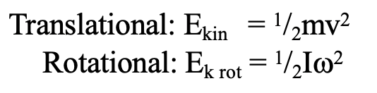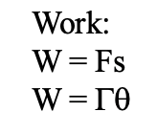
Example: A 23.7 kg 45 cm radius cylinder is rolling at 13.5 m/s at the bottom of a hill.
What is its translational kinetic energy?

What is its rotational kinetic energy?

What is the total kinetic energy? What was the height of the hill?

Whiteboards
1. What is the rotational kinetic energy of an object with an angular velocity of 12.0 rad/s, and a moment of inertia of 56.0 kg m²?  (4.0 x 10³ J) | 2. What must be the angular velocity of a flywheel that is a 22.4 kg, 54 cm radius cylinder to store 10,000. J of energy?  (78 rad/s)
3. What is the total kinetic energy (Translational and rotational) of a 2.5 cm diameter 405 g sphere rolling at 3.5 m/s?  (3.5 J) | 4. If you exert 14.0 mN of torque through 3.10 rotations on a potter’s wheel that is a 26.0 kg, 68.0cm diameter uniform cylinder, what will be the final angular velocity?  (19.1 rad/s)

