Noteguide for Moment Of Inertia (Videos 8G) Name

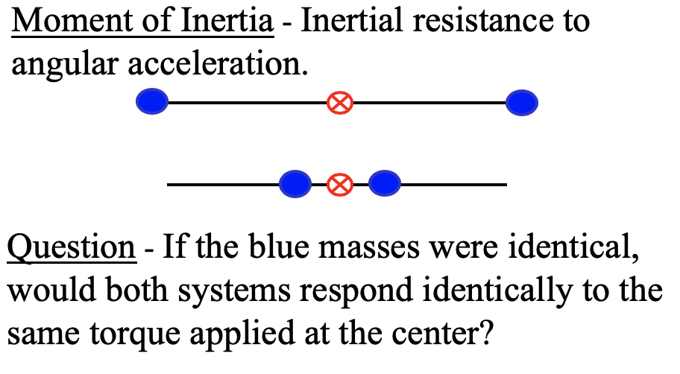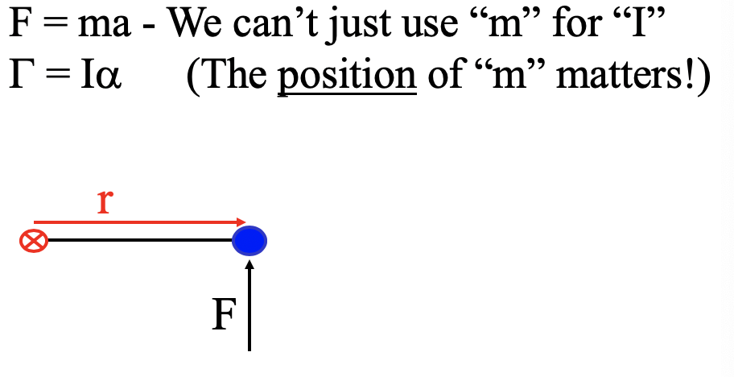

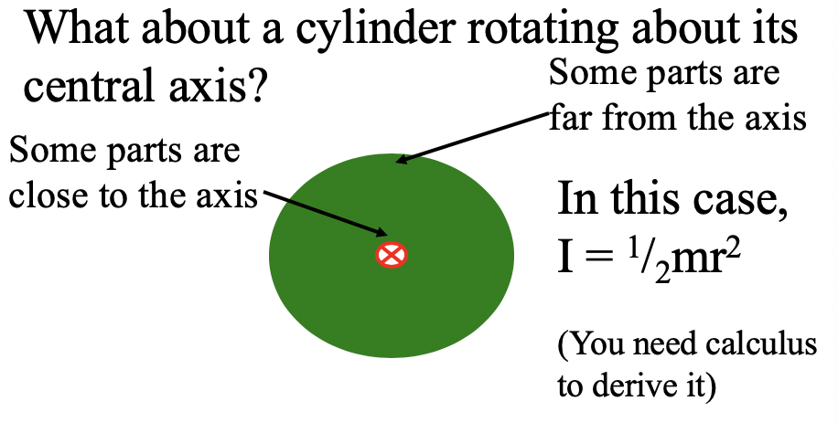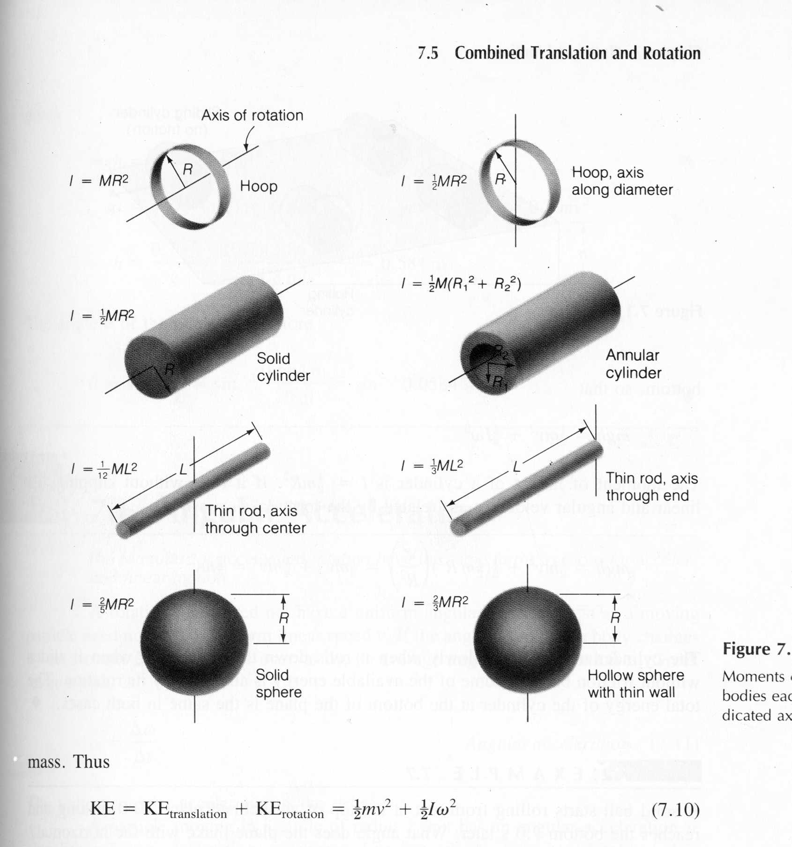

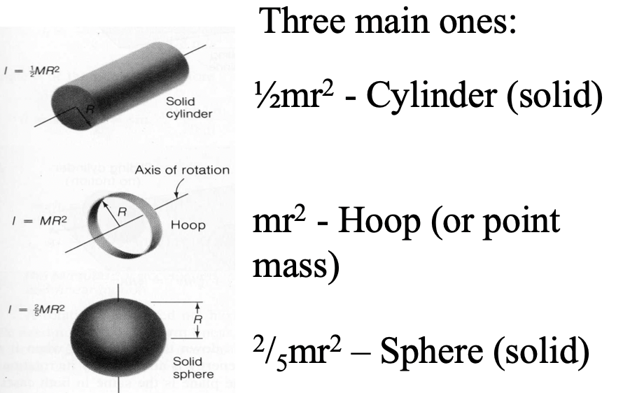

Example: Three 40. kg children are sitting 1.2 m from the center of a merry-go-round that is a uniform cylinder with a mass of 240 kg and a radius of 1.5 m. What is its total moment of inertia?

(Whiteboards on the back)

Whiteboards;
1. What is the moment of inertia of a 3.5 kg point mass that is 45 cm from the center of rotation?  (0.71 kg m²) | 2. A uniform cylinder has a radius of 1.125 m and a moment of inertia of 572.3 kg m². What is its mass?  (904.4 kg)
3. A sphere has a mass of 45.2 grams, and a moment of inertia of 5.537 x 10⁻⁶ kg m². What is its radius?
(0.0175 m)

