IB Physics
Linear Momentum
Chapter 7 Syllabus
A/B | In Class: |  | Due on this class
1  Jan  7/8 | DI-What do rockets push on?  GW-Impulse and Rocket Science |  | VF 7A, 7B, 7C, 7D
2  Jan  9/10 | SA7.1 - Impulse and Momentum (first 30 min)  VF-7E - Conservation of momentum  DI-Conservation of momentum/VF for COM lab |  | Turin in: FA7.1
3  Jan  13/14 | DI-Demos - Car design  GW-Vector Momentum Lab  GW-Conservation of Momentum Lab  GW-Conservation of Momentum problems (7.2) |  | VF 7E  VF First video for COM lab  VF First two videos for Vector Momentum
4  Jan  15/16 | DI-Demos - Tunnel of Transmogrification  GW-Vector Momentum Lab  GW-Conservation of Momentum Lab  GW-Conservation of Momentum problems (7.2)  GW-Energy and Momentum problems (7.3) |  | VF 7F
5  Jan  17/21 | DI-Demos - Cannon/Match rockets/Angular Sheet  DI-Demos - Angular Quantities  GW-Vector Momentum Lab  GW-Conservation of Momentum Lab  GW-Conservation of Momentum problems (7.2)  GW-Energy and Momentum problems (7.3) |  | VF 8A Angular Quantities  VF 8B Angular Conversions  VF 8C Tangential Relationships
6  Jan  28/29 | GW-7.2, 7.3, 8.1  DI-Torque and Moment of Inertia demos | Turn in: Angular Quantities 8.0 (At beginning of period!)  VF 8ABC, 8D, 8E
7  Jan 30/31 | SA7.2 Conservation of Momentum  SA7.3 Energy and Momentum | Turn in: FA7.2, FA7.3  Turn in: Vector Momentum and COM labs
 | Finals
@%#$  Feb  3/4 | Valuable Standardized Testing (VST)
2  Feb  5/6 | (some people finish up VST)  GW-8.2 Angular Dynamics  GW-FA8.2 | VF 8F-Torque, 8G-Moment of Inertia
3  Feb  7/10 | SA8.2-Angular Dynamics (first 30)  VF-8I Rolling Dynamics  DI-Rolling Dynamics Demo/Example | Turn in: FA8.2
2  Feb  11/12 | More Exciting Angular Stuff
3 Labs:
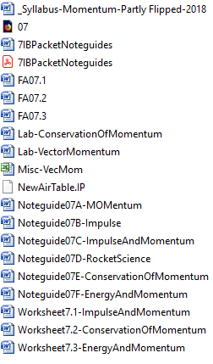
- Cannon Lab (mini lab done in-class) /10 pts
- Conservation of momentum lab (with the air track – collision of gliders) /40 pts
- Vector Momentum Lab – 2-D vector momentum collision (simulation from the computer) /30 pts
3 Formative/Summative Assessments
- 7.1 – Impulse and momentum
- 7.2 – Conservation of momentum
- 7.3 – Energy and Momentum

