Noteguide for Conservation of Momentum (Videos 7E) Name
Why is momentum conserved:
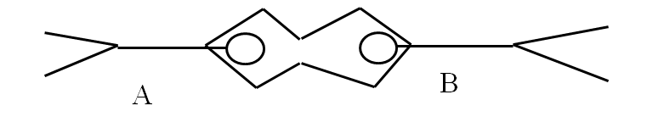

Example 1: A 4.30 g bullet travelling 925 m/s horizontally strikes and sticks in a 121 g block of wood. What is the velocity of the bullet and block after the collision?

Example 2: 60.0 kg Brennen is at rest on a 352 kg flatbed cart. He runs to the right and is going 5.30 m/s before he leaps from the car. What is the recoil velocity of the flatbed car? Ignore the friction of the wheels.

Example 3: A 2560 kg Mazda Protégé going 27.0 m/s strikes a Ford Escort traveling 13.0 m/s in the same direction from behind. The two cars stick together and are going 20.6 m/s after the collision. What is the mass of the Escort?

Example 4: Bumper car A (450 Kg) with velocity 2.90 m/s East collides with the front of car B (580. Kg) which has a velocity of 3.40 m/s West. After the collision, car B has a velocity of 1.20 m/s to the East. What is the velocity of car A after the collision? (Speed and direction)

Whiteboards:
1. 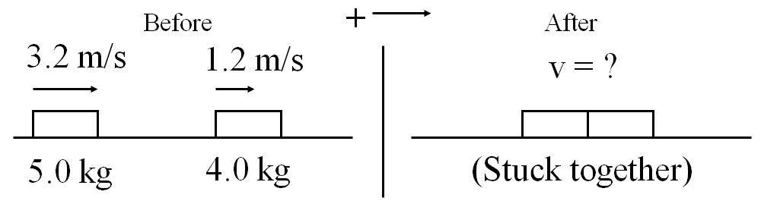(2.3 m/s to the right)

2. 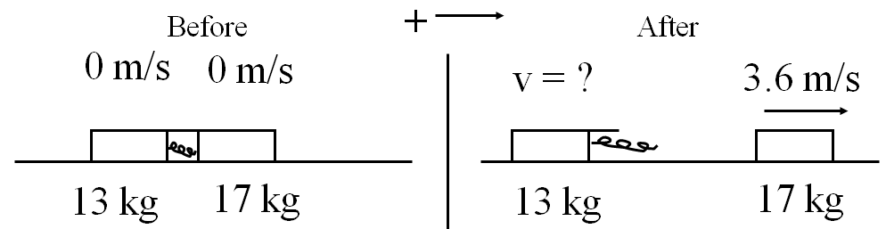 (4.7 m/s to the left)

3. 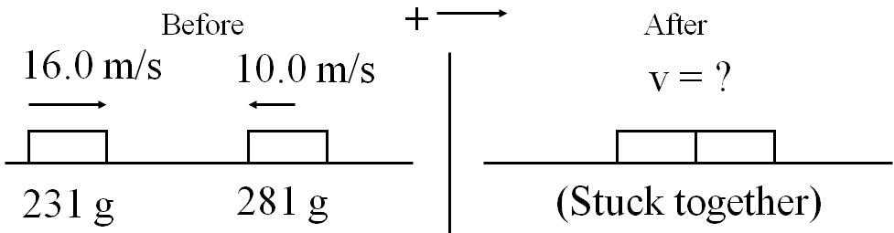 (1.73 m/s to the right)

4. 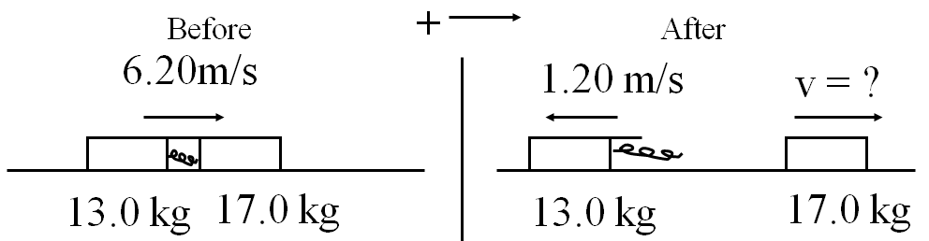 (11.9 m/s to the right)

