Noteguide for Impulse and Momentum (Videos 7C) Name

Impulse = Change in momentum
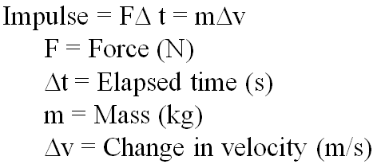
Example: A pitcher pitches a 0.145 kg baseball at 40. m/s, and the batter hits it directly back at 50. m/s to the outfield. What is the average force exerted by the bat if the collision lasted 0.013 s?

Deriving Newton’s second law:

Whiteboards:
1. What force for 10. seconds makes a 2.0 kg rocket speed up to 75 m/s from rest? (15 N) | 2. A baseball bat exerts a force of 200. N on a .50 kg ball for .10 seconds. What is the ball’s change in velocity? (40 m/s)
3. Jolene exerts a 50. N force for 3.0 seconds on a stage set. It speeds up from rest to 0.25 m/s. What is the mass of the set? (600 kg) | 4. A pitcher pitches a 0.145 kg baseball at 35.0 m/s, and the batter hits it directly back at 42.0 m/s to the outfield. The bat exerts an average force of 892 N on the ball. For what time does the collision last? (0.0125 s)

