Noteguide for Impulse (Videos 7B) Name

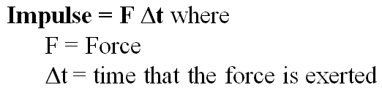
Impulse (change in momentum)
Example: What impulse is imparted by exerting a 12 N force for 4.0 s?

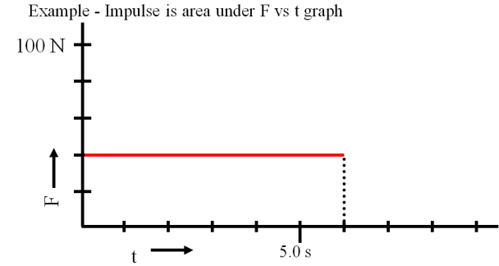

Whiteboards:
1. What is the impulse of a 6.12 N force acting for 2.3 seconds (14 N s) | 2. A rocket engine is rated at 14 N s of impulse, and burns for 1.7 seconds. What is the thrust of the engine? (8.2 N)
3. 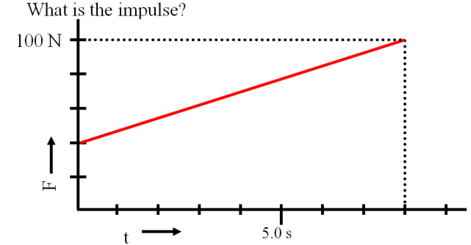  (560 N s) | 4. 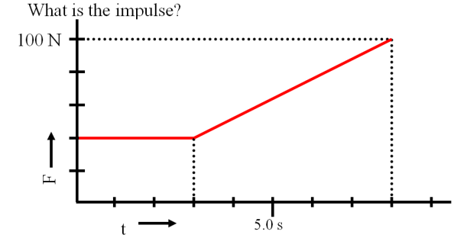  (470 N s)

