IB Physics
FA6.0 - Work and Energy
Name

Favorite TV series
Show your work, and circle your answers to receive full credit.
1. Rilla Fordable does 312 J of work exerting 54.0 N of force for what distance? (5.78m)

2. What speed must a 0.458 kg hammer go to have 60.0 J of kinetic energy? (16.2 m/s)

3. What is the potential energy of a 2.60 kg clock weight that is 1.45 m above its lowest point? (37.0 J)

4. What is the kinetic energy of a 0.145 kg baseball going 40.0 m/s? (116 J)

5. What distance must you stretch a 35.0 N/m spring to store exactly 5.00 J of energy? (53.5 cm)

Practice 6.0 - Work and Energy
 | Work: W = Fs
144 J | 1. How much work does Fred do exerting 45.0 N to lift a box 3.20 m?
60.0 J | 2. How much work does Adair lifting a 12.0 N box up 5.00 m?
138 m | 3. An alkaline AA battery contains 9360 J of energy. If it takes 68.0 N of force to drag a heavy box across the floor, how far could the energy in a AA battery drag the box?
1.56 m | 4. What vertical distance will 64.0 J of work lift a box that weighs 41.0 N
0.694 N | 5. Katherine moves a box 7.20 m doing 5.00 J of work. What is the frictional force?
28.5 N | 6. What force exerted for 4.10 m does 117 J of work?
 | Potential Energy: PE = mgh
636 J | 7. What is the potential energy of a 5.40 Kg shot put that is 12.0 m in the air?
21.3 J | 8. What is the potential energy of a 3.20 kg clock weight that has been wound up to a height of 0.680 m?
162 Kg | 9. What is the mass of a pile driver if it has 13,200 J of PE when it is 8.30 m in the air?
68.0 kg | 10. What mass has a PE of 140. J when it is at an elevation of 0.210 m?
13.3 m  (43.5 feet) | 11. An alkaline AA battery contains 9360 J of energy. If I connected it to a 100% efficient winch, how high could it lift a 72.0 kg person?
19.0 m | 12. To what height must a 0.145 Kg baseball rise to get a potential energy of 27.0 J?
 | Kinetic energy: KE = ¹/₂mv²
116 J | 13.What is the kinetic energy of a 0.145 Kg baseball going 40.0 m/s? (about 90 mph)
2634 J | 14. What is the kinetic energy of a 4.20 g (0.0042 kg) bullet going 1120 m/s?
359 m/s  (mach 1.05) | 15.An alkaline AA battery contains 9360 J of energy. If I connected it to a 100% efficient pitching machine, how fast could it pitch a 0.145 kg baseball?
15.9 m/s | 16. What speed must a 0.450 Kg hammer have to have a kinetic energy of 57.0. J?
172 kg | 17. A pile driver must develop 14,500 J of kinetic energy when it is going 13.0 m/s. What does its mass have to be?
0.00689 Kg  (6.89 g) | 18. A bullet with a speed of 892 m/s has a kinetic energy of 2740 J. What is its mass?
 | Springs: F = kx
4.06 N | 19. What force do you need to stretch a 31.2 N/m spring 13.0 cm?
42.8 N/m | 20. You hang a 200. gram mass on a spring, and it stretches 4.58 cm. What is its spring constant in N/m? (F = mg, 1000 g = 1 kg, 100 cm = 1 m)
31.9 cm | 21. If you exert 15.0 N on a spring with a constant of 47.0 N/m how many centimeters will it stretch?
 | Springs: PE = ¹/₂kx²
83.3 J | 22. What is the energy stored in a bow with a constant of 371 N/m if you stretch it 67.0 cm?
944 N/m | 23. A spring has a potential energy of 6.80 J when it is stretched 12.0 cm. What must be the spring constant?
0.620 m or  62.0 cm | 24. What distance must you compress a 78.0 N/m spring to store 15.0 J of energy?

Quizlette 6.2 - Conservation of Energy with Pictures Name
(Remember, the test will not have any pictures - so you need to work on the practice 6.2 when you are done with this)
Fs + mgh + ¹/₂mv² = Fs + mgh + ¹/₂mv²
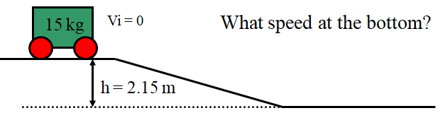(6.49 m/s)

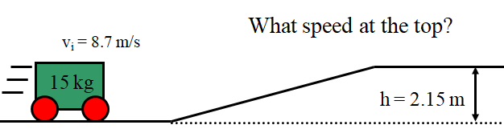 (5.79 m/s)

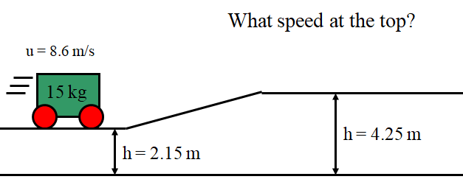 (5.72 m/s)

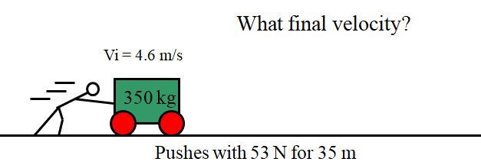 (5.64 m/s)

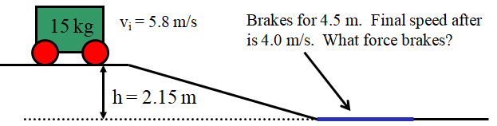(99.7 N)

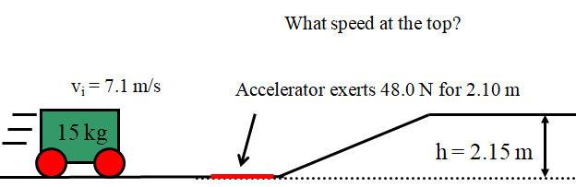 (4.65 m/s)

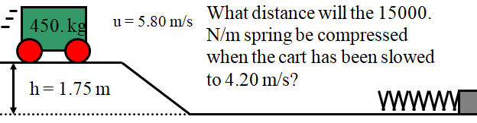 (1.23 m)

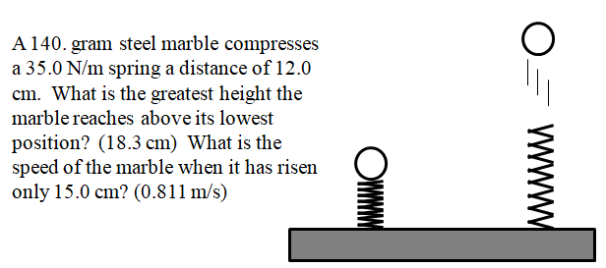

IB Physics
FA6.2 - Conservation of Energy
Name

Favorite Palindrome

Show your work, and circle your answers and use sig figs to receive full credit.
1. A 5.20 kg object speeds up from 3.10 m/s to 4.20 m/s. What is the change in kinetic energy?

If a 45.0 N/m spring is compressed 35.0 cm, what is its compression when it has released 2.00 J of potential energy from this point?

A clock uses a 4.28 kg mass to store energy. If it goes from a height of 1.85 m from the floor to a height of 1.12 m from the floor, how much energy did it release?

2. A massless spring with a spring constant of 34.0 N/m is compressed 5.80 cm horizontally and used to shoot an 18.0 gram marble across a frictionless table. What is the speed of the marble?

3. A 3.40 kg bowling ball hanging from the ceiling on a long string swings from side to side like a pendulum. When it is at rest 15.0 cm above its lowest point on the left side, I shove it from rest with a force of 11.0 N for a distance of 0.350 m in the direction it is going. How high will it swing on the other side? (Neglect friction)

4. A 580. kg rollercoaster is going 7.50 m/s on the top of a 1.20 m tall hill, how fast is it going on top of a 3.50 m tall hill? (Neglect friction) (3.34 m/s)

Conservation of Energy Questions from A6.2
0.992 m  62.6 N  13.7 m/s  7.04 m/s | 1. a. A 26.0 N/m spring is stretched 0.650 m. If it is given 7.30 J more potential energy, how much has it been stretched?  b. A baseball pitcher speeds a 0.145 kg ball from rest to 39.2 m/s over a distance of 1.78 m. What must be the average force exerted on the ball? (Neglect friction or any change in elevation)  c. A 1350 kg car is moving at some speed at an elevation of 4.62 m partway up a hill, and then coasts to a stop at an elevation of 14.2 m. How fast was it going at 4.62 m elevation? (Neglect friction)  d. A 125 kg sled is going 3.31 m/s at the top of a 2.65 m tall hill. At the bottom it hits a patch of dirt that exerts a slowing force of 137.2 N for 6.12 m. How fast is the sled going after the dirt patch? (Neglect friction)
14.1 m/s  8.88 m  64.2 N  2.19 m | 2. a. A 0.570 kg hammer is going 9.80 m/s. How fast is it going if it is given 29.0 more J of kinetic energy?  b. A 1540 kg car starts at rest and rolls down a hill. At the bottom it is going 13.2 m/s. How high was the hill? (Neglect friction)  c. Mom gives 48.0 kg Tamara a push from rest on her massless sled for a distance of 7.60 m at the top of a 3.40 m tall hill. If she is going 9.33 m/s at the bottom of the hill, what force did Mom exert at the top to speed her up? (Neglect friction)  d. A 421 kg rollercoaster car going 3.54 m/s hits an accelerator that exerts a force of 718 N to speed up the car over a distance of 14.9 m. The car then rolls up a hill where it is going 4.52 m/s. What is the height of the hill? (Neglect friction)
9.62 J  5.39 m  6.08 m/s  5.80 m | 3. a. A 37.0 N/m spring is compressed 1.40 m. How much energy is released if it is allowed to expand so that it is compressed only 1.20 m?  b. A 0.145 kg ball compresses a massless spring with a constant of 38.0 N/m a vertical distance of 0.635 m, and is then released so that it shoots straight up. To what maximum height does the ball rise above its lowest position with the spring compressed? (Neglect friction)  c. A 0.145 kg ball compresses a massless spring with a constant of 38.0 N/m a vertical distance of 0.635 m, and is then released so that it shoots straight up. What is the velocity of the ball when it has risen a distance of 3.50 m above its lowest point? (Neglect friction)  d. A 748 kg rollercoaster car is going 8.50 m/s at the top of a 3.15 m tall hill. At what height is it when it is going 4.50 m/s? (Neglect friction)
13.8 m  18.9 m/s  7.69 m/s  7.05 m | 4. a. A 5.60 kg mass is 3.80 m above the ground. What is its height after it has gained 550. J more of potential energy?  b. A 0.145 kg baseball is popped straight up, and goes 18.3 m in the air before coming back down. What was its initial velocity? (Neglect friction)  c. A 1725 kg car going 13.7 m/s on a level road strikes a 1540 N/m spring that slows it down. What is the velocity of the car when it has compressed the spring 12.0 m? (Neglect friction)  d. A 657 kg Rollercoaster car at rest on top of a 4.63 m tall hill is sped up by a force of 7480 N for a distance of 4.50 m. What is the height of the car when it is going 7.42 m/s (Neglect friction)
1.50 J  0.273 m  0.661 m  9.71 m/s | 5. a. A 0.145 kg baseball speeds up from 6.70 m/s to 8.10 m/s. What is the change in kinetic energy?  b. Ferdinand exerts a force of 153.3 N for a distance of 21.5 m on the level speeding up a 1230 kg car initially at rest. The car then rolls up an incline. How much elevation will the car gain before it stops? (Neglect friction)  c. Reginald exerts a force of 179.5 N for a distance of 55.0 m on the level speeding up a 1027 kg car from rest. The car then rolls up an incline. What elevation has the car gained when it has a velocity of 2.50 m/s? (Neglect friction)  d. A 415 kg roller coaster car initially at rest is launched from the top of a 4.31 m tall hill by a 1890 N/m spring compressed a distance of 5.75 m. What is the speed of the car when it is at the top of a 7.18 m tall hill? (Neglect friction)

IB Physics
FA6.1 - Work and Power
Name

Favorite YouTube Video (besides physics)
When you have finished this, go to the website and check your answers. If you got a problem wrong, cross it off on the front, and do it correctly on the back.
Show your work, and circle your answers and use sig figs to receive full credit.
1. If a heater is 78.0% efficient, how much fuel energy would it consume to provide 120. J of useful heat? How much useful heat could it produce from 360. J of fuel energy?

2. How much time does it take for a 450. Watt heater to produce 4580 J of heat? What heat will it produce in 15.0 seconds?

3. What work would you do dragging a 56.5 kg box 12.0 m over a level floor (at a constant low speed) where the coefficient of dynamic friction is 0.215?

4. What is the minimum power rating a motor could have if it is to lift a 560. kg elevator 35.0 m in 78.0 seconds?

Work and Power Questions from A6.1
0.856, 380. J  45.0 W, 2700 J  9.32 m  282 s | 1. a. A heater consumes 125 J of fuel and produces 107 J of useful heat. What is its efficiency? How much fuel would it consume to produce 325 J of useful heat?  b. A motor does 585 J of work in 13.0 seconds. What is its power output? What work could it do in 60.0 seconds?  c. You do 412 J of work dragging a 26.5 kg box over a level floor (at a constant low speed) where the coefficient of dynamic friction is 0.170. What distance did you drag it?  d. What is the minimum time a 540. W motor can lift a 3450 kg land rover 4.50 m?
567 J, 408 J  80.4 W, 19.0 s  3.20 m  406 W | 2. a. A heater is 91.0% efficient. How much useful heat would it produce from 623 J of fuel energy? How much fuel would it consume to produce 371 J of useful heat?  b. A motor does 965 J of work in 12.0 seconds. What is its power output? In what time could it do 1530 J of work?  c. You do 371 J of work lifting a 11.8 kg box. What height did you lift it?  d. What is your power output if you drag a 87.0 kg sled a level distance of 43.0 m in 19.0 s where the coefficient of dynamic friction is 0.210?
0.916, 591 J  5040 J, 1.80 s  9.96 kg  43.8 s | 3. a. A heater consumes 215 J of fuel and produces 197 J of useful heat. What is its efficiency? How much useful heat would it produce from 645 J of fuel energy?  b. What work does a 420. W motor do in 12.0 seconds? What time would it take the motor to do 758 J of work?  c. You do 850. J of work raising what mass a vertical distance of 8.70 m?  d. A sled dog has a power output of 310. W. In what time can it drag a 112 kg sled 95.0 m across a frozen lake where the coefficient of friction is 0.130?
204 J, 584 J  51.6 W, 6970 J  15.0 kg  674 W | 4. a. A heater is 82.0% efficient. How much fuel would it consume to produce 167 J of useful heat? How much useful heat would it produce from 712 J of fuel energy?  b. A motor does 568 J of work in 11.0 seconds. What is its power output? What work could it do in 135. seconds?  c. You do 381 J of work dragging a box 23.5 m over a level floor (at a constant low speed) where the coefficient of dynamic friction is 0.110. What is the mass of the box?  d. What is the minimum power rating a motor can have if it needs to lift a 2350 kg SUV a vertical distance of 4.50 m in 154 s?
0.945, 912 J  1890 J, 7.00 s  0.137  135 s | 5. a. A heater consumes 618 J of fuel and produces 584 J of useful heat. What is its efficiency? How much fuel would it consume to produce 862. J of useful heat?  b. What work does a 118 W motor do in 16.0 seconds? What time would it take the motor to do 826 J of work?  c. You do 645 J of work dragging a 15.0 kg box over a level floor (at a constant low speed) a distance of 32.0 m. What was the dynamic coefficient of friction?  d. What is the minimum time a 746. W motor can lift a 2770 kg land rover 3.70 m?

