Quizlette 6.2 - Conservation of Energy with Pictures Name
(Remember, the test will not have any pictures - so you need to work on the practice 6.2 when you are done with this)
Fs + mgh + ¹/₂mv² + ¹/₂kx² = Fs + mgh + ¹/₂mv² + ¹/₂kx²
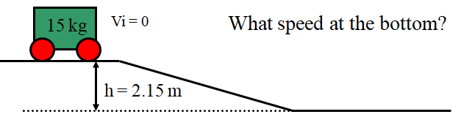(6.49 m/s)

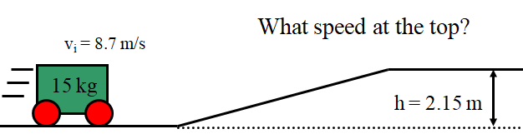 (5.79 m/s)

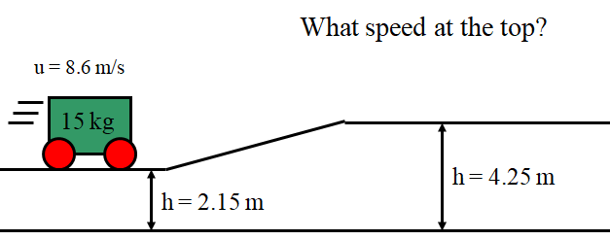 (5.72 m/s)

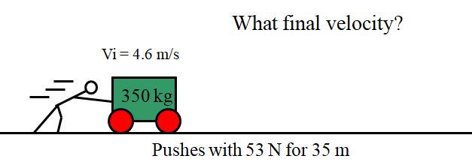 (5.64 m/s)

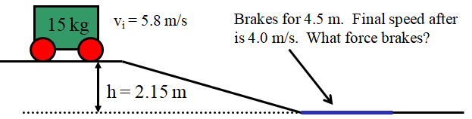(99.7 N)

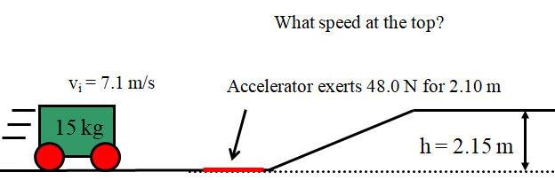 (4.65 m/s)

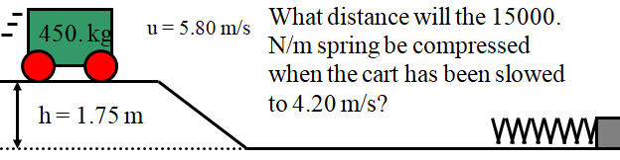 (1.23 m)

