Noteguide for Work and Power (Videos 6I) Name

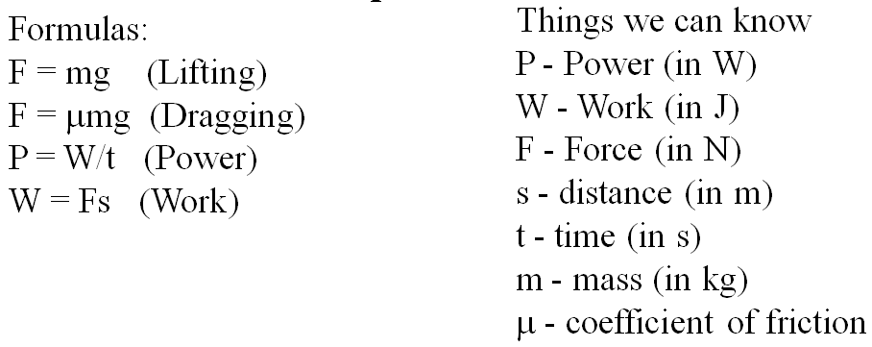
Example 1 - A 840 W winch can lift a 2350 kg Land Rover up 8.2 m into a tree in what time?

Example 2 - Gumi Baere drags a 45.1 kg box that has a coefficient of friction between it and the floor of 0.34 a distance of 16 m in 11.7 seconds. What is her power output?

Whiteboards:
1. What must be the power rating of a motor if it is to lift a 560 kg elevator up 3.2 m in 1.5 seconds? (11,700 W) | 2. A 560. W winch can lift a car 5.2 m in 37 seconds. What must be the mass of the car?  1 HP = 745.7 W (407 kg)
3. Red Elk leads a dog team that can put out 2.5 kW of power. They skid a 312 kg sled a distance of 340 m in 93 seconds. What must be the coefficient of friction? (0.22) | 4. A 50.0 HP tractor can drag a 982 kg load how far in a minute if the coefficient of friction between the load and the ground is 0.780.  1 HP = 745.7 W (298 m)

