Noteguide for Power (Videos 6H) Name

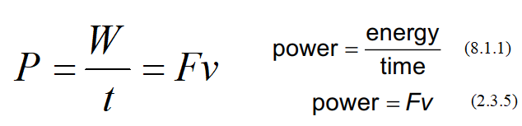
A person does 48 J of work in 6.0 s. What is their power output?

Examples
How much energy does a 75 Watt light bulb consume in a minute? (60 s) | My 30. HP van could go 25 m/s top speed. What was the force resisting its motion?  1 horsepower = 745.7 Watts, 1 kW = 1000 Watts

Whiteboards:
1. Joe Mama does 613 J of work in 2.13 seconds. What is his power output? (288 W) | 2. Ima Wonder can put out 127 W of power. What time will it take her to do 671 J of work? (5.28 s)
3. What work does a 1.5 HP motor do in 1 minute?  (1 hp = 745.7 W) (67,000 J) | 4. Bob N. Frappels slides a box with 43 N of force at a constant speed of 5.3 m/s. What is his power output? (230 W)
5. Frieda People can put out 430. W of power. With what speed can she push a car if it takes 152 N to make it move at a constant velocity? (2.83 m/s)

