Name:______________________________________________ Date:_____________ Period:________
Plate Lab
Goal: to analyze the forces needed for circular motion and
understand what happens when those forces are removed.

A marble on a plate can be made to go in a circle. Push a marble along the edge of a whole (uncut) plate and think about and answer the questions below. For this activity, the drawings and images will be from the viewpoint directly above the plate looking down.

After your push, what is the force causing this circular motion? _______________
In the diagram below, imagine the ball is going anti-clockwise. Draw an arrow representing the instantaneous velocity at this point. Label it "V". Draw another arrow showing the direction of the force acting on the marble to make it go in a circle. Label it "F". Also label which way you think the acceleration is with an arrow labeled "a"
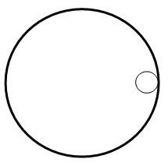
A second plate has a section cut out of it. If you give the marble a push near the top so that it travels along the plate counter-clockwise, predict what path you think the marble take when it exits the plate. Draw the predicted path on the picture below. Write a short sentence why you think this will happen.

Predicted: Actual:
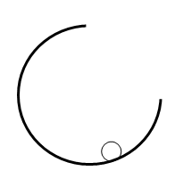
Test out your guess with the plate and marble. Do the experiment several times to make sure you know what actually happens. Draw the path it actually takes.

5.1 Quizlette - Centripetal Force and Acceleration Name
Velocity - radius equation
1. What is the centripetal acceleration of a skier going 23.0 m/s around a corner with a radius of 56.0 m? (9.45 m/s/s)

2. A car going around a corner with a radius of 340. m is accelerating laterally at 6.40 m/s/s. What is its speed? (46.6 m/s)

3. A car goes 23.0 m/s around a corner with a lateral acceleration of 4.50 m/s/s. What is the radius of the corner? (118 m)

Period - radius equation
4. A centrifuge has a radius of 0.0870 m, and a period of 0.0230 s. What is its centripetal acceleration? (6493 m/s/s)

5. A centrifuge generates a centripetal acceleration of 3760 m/s/s with a period of 0.0310 s. What is the radius of the centrifuge? (0.0915 m)

6. A centrifuge generates an acceleration of 9250 m/s/s with a radius of 0.0680 m. What is its period of motion? (0.0170 s)

, so and Centripetal force
7. What centripetal force do you need to make a 78.0 kg skier go 39.0 m/s around a 98.0 m radius corner? (1211 N)

8. What is the maximum velocity you can twirl a 3.90 kg hammer in a 1.80 m radius circle if the string it is attached to has a tensile strength of 190. N? (9.36 m/s)

9. A centrifuge makes 0.0140 kg test tubes go in a 0.0860 m radius circle with a period of 0.0455 s. What force does it exert on the test tubes? (23.0 N)

10. A centrifuge exerts 213 N on a 0.0120 kg test tube spinning in a 0.0750 m radius circle. What is its period of motion?
(0.0129 s)

Friction provides centripetal force:
11. A 1450 kg car with a coefficient of friction of 0.870 goes around a level corner at 27.0 m/s. What is the minimum radius the corner can have? (85.4 m)

12. There is a coefficient of friction of 0.930 between a 1230 kg car and the level road. What is its maximum possible
velocity around a 330. m radius corner? (54.9 m/s)

13. A 0.120 kg mass is on a level turntable. If there is a coefficient of friction of 0.340 between the turntable and the mass, and the turntable has a period of 1.33 s, what is the maximum distance the mass can be from the center and not fly off?
(0.149 m)

14. A 0.0110 kg eraser is on a level turntable 0.180 m from the center. If there is a coefficient of friction of 0.880 between the turntable and the eraser, what is the minimum period of motion the turntable can have for the eraser to remain without flying off?
(0.907 s)

IB Physics
FA 5.1 - Centripetal Acceleration
Name
Show your work, round to the correct significant figures, circle your answers, and label them with units.
1. With what maximum velocity can a car go around a 324 m radius curve if it cannot exceed 0.330 “g”s of lateral acceleration? (32.4 m/s )

2. A Centrifuge has a radius of 5.80 cm, and spins at 2500. RPM. What is the centripetal acceleration?
(3980 m/s/s)

3. What centripetal force would make a 110. kg bike and rider go 14.0 m/s around a 25.0 m radius corner? (862 N)

4. A spinning carnival ride has a radius of 3.20 m. What is the period of the ride if it is exerting a centripetal force of 918 N on a 52.0 kg person? (2.68 s)

5. What is the minimum coefficient of friction needed for a 1198 kg car to go 25.0 m/s around a level corner with a radius of 310. m? What about a 3150 kg SUV? (0.206, 0.206)

IB Physics
FA 5.2 - Vertical Circle
Name
Show your work, round to the correct significant figures, circle your answers, and label them with units. Use the convention that up is positive.
When you have finished this, go to the website and check your answers. If you got a problem wrong, cross it off on the front, and do it correctly on the back.
1. A carnival ride moves at a constant speed in a vertical circle. If the riders are feeling 0.85 "g"s inverted at the top, what "g"s do they feel at the bottom, and what is the actual centripetal acceleration of the ride in "g"s? (Be sure to answer both questions)

2-3: A 2.50 kg mass moves at a constant speed in a vertical circle at the end of a 0.310 m long rod with a period of 1.30 s.
2. What force in what direction does the rod exert at the top?

3. What force in what direction does the rod exert at the bottom?

4-5: A 1.20 kg mass moves in a 0.45 m radius circle at a constant speed. At the top this requires a downward force of 5.75 N
4. What is its velocity?

5. What force in what direction is required at the bottom?

Vertical Circle Questions from A5.2
Use the convention that up is positive. For all the forces, label them "up" or "down"
-0.60 "g"s  1.60 "g"s  8.51 N (up)  95.5 N (up)  7.84 s  38.7 N (up) | 1. a. A carnival ride moves at a constant speed in a vertical circle. If the riders are feeling 2.60 "g"s at the bottom, what "g"s do they feel at the top, and what is the actual centripetal acceleration of the ride in "g"s? (Be sure to answer both questions)  b-c: A 5.30 kg mass moves at a constant speed in a vertical circle on the end of a 0.440 m long rod with a velocity of 1.90 m/s.  b. What force in what direction does the rod exert at the top?  c. What force in what direction does the rod exert at the bottom?  d-e: A 2.60 kg mass moves at a constant speed in a 7.90 m radius vertical circle on the end of a rod. At the top this requires an upward force of 12.3 N.  d. What is the period of the mass?  e. What force in what direction is required at the bottom?
0.88 "g"s  1.12 "g"s  -7.14 N (down)  42.5 N (up)  3.78 m/s  2.09 N (up) | 2. a. A carnival ride moves at a constant speed in a vertical circle. If the actual centripetal acceleration of the ride in "g"s is 0.12 "g"s, what “g”s do the riders feel at the top, what "g"s do they feel at the bottom? (Be sure to answer both questions)  b-c: A 1.80 kg mass moves in a vertical circle at a constant speed with a period of 3.30 s on the end of a 3.80 m long rod.  b. What force in what direction does the rod exert at the top?  c. What force in what direction does the rod exert at the bottom?  d-e: A 2.40 kg mass moves in a vertical circle at a constant speed on the end of a 1.60 m long rod. At the bottom this requires an upward force of 45.0 N  d. What is the speed of the mass?  e. What force in what direction is required at the top?
2.31 "g"s  1.31 "g"s  9.43 N (up)  31.8 N (up)  2.89 s  -2.46 N (down) | 3. a. A carnival ride moves at a constant speed in a vertical circle. If the riders are feeling 0.31 "g"s inverted at the top, what "g"s do they feel at the bottom, and what is the actual centripetal acceleration of the ride in "g"s?  (Be sure to answer both questions)  b-c: A 2.10 kg mass moves at a constant speed in a vertical circle on the end of a 0.910 m long rod at 2.20 m/s.  b. What force in what direction does the rod exert at the top?  c. What force in what direction does the rod exert at the bottom?  d-e: A 1.20 kg mass moves at a constant speed in a vertical circle on the end of a 2.50 m long rod. This requires 26.0 N of upward force at the bottom.  d. What is the period of the mass?  e. What force in what direction is required at the top?
0.62 "g"s  1.62 "g"s  0.794 N (up)  28.6 N (up)  2.12 s  25.1 N | 4. a. A carnival ride moves at a constant speed in a vertical circle. If the riders feel 0.38 "g"s at the top, what is the centripetal acceleration of the ride in "g"s, and what "g"s do they feel at the bottom (Be sure to answer both questions)  b-c: A 1.50 kg mass moves at a constant speed of 2.30 m/s in a vertical circle with a radius of 0.570 m on the end of a rod.  b. What force in what direction does the rod exert at the top?  c. What force in what direction does the rod exert at the bottom?  d-e: A 1.60 kg mass moves at a constant speed in a 0.670 m radius circle on the end of a rod. At the top this requires an upward force of 6.30 N.  d. What is the period of motion of the mass?  e. What force in what direction is required at the bottom?
-1.34 "g"s  2.34 "g"s  -15.4 N (down)  42.9 N (up)  2.90 m/s  50.0 N (up) | 5. a. A carnival ride moves at a constant speed in a vertical circle. If the riders are feeling 3.34 "g"s at the bottom, what "g"s do they feel at the top, and what is the actual centripetal acceleration of the ride in "g"s? (Be sure to answer both questions)  b-c: A 1.40 kg mass moves in a vertical circle at a constant speed on the end of a 0.760 m long rod with a period of 1.20 s.  b. What force in what direction does the rod exert at the top?  c. What force in what direction does the rod exert at the bottom?  d-e: A 2.20 kg mass moves in a vertical circle on the end of a rod with a radius of 0.650 m. At the top this requires a downward force of 6.80 N.  d. What is the velocity of the mass?  e. What force in what direction is required at the bottom?

Orbit Problems: Name
1. What is the orbital velocity 3400 m from the center of a 5.6 x 10¹⁸ kg asteroid? (331.4 ≈ 330 m/s)

2. You find that you can orbit at 516 m/s 12,150 m from the center of a small moon. What is its mass? (4.85 x 10¹⁹ kg)

3. A satellite orbits a planet at a distance of 7.5 x 10⁶ m from the center every 8900 seconds. What is the mass of the planet? (3.2 x 10²⁴ kg)

4. What distance from the center of Earth’s moon is your orbital velocity 120 m/s? (3.4 x 10⁸ m)

5. What is the period of orbit of a satellite that orbits 1.95 x 10⁶ m from the center of Earth’s moon? (7730 s)

6. What is the radius of an orbit with a period of 3.16 x 10⁷ s around the sun? (1.50 x 10¹¹ m – yep – it’s the earth)

Use or Which come from: , and and

Useful things to know:
Mass of the Earth | 5.97x10²⁴ kg | Radius of the Moon | 1.738x10⁶ m
Mass of the Moon | 7.35x10²² kg | Radius of the Earth | 6.38x10⁶ m
Mass of the Sun | 1.99x10³⁰ kg | Earth-Moon Distance | 3.84x10⁸ m
G = 6.67 x 10⁻¹¹ Nm²/kg² |  | Earth-Sun Distance | 1.496x10¹¹ m

IB Physics
FA 5.3 - Orbit
Name
Show your work, round to the correct significant figures, circle your answers, and label them with units.
When you have finished this, go to the website and check your answers. If you got a problem wrong, cross it off on the front, and do it correctly on the back.
1. What is the force of gravity between the Philae probe with a mass of 100. kg and comet 67P with a mass of 1.05x10¹³ kg if the probe is resting on the surface of the 2.05 km (2.05x10³ m) radius comet. (That we will pretend is spherical - it's highly not)

2. What distance needs to separate the centers of two 5.20 kg spheres so that the force of gravity between them is 1.20x10⁻⁹ N

3. Your 12,500 kg spaceship is orbiting 1.16x10⁷ m from the center of a planet every 17,500 s. What is the mass of the planet?

4. At what distance from the center of our 7.35x10²² kg moon is the orbital velocity 340. m/s?

5. Draw the new orbit: (Circle or oval indicates your current orbit)
Slow at x: Speed up at x: Speed up at x:
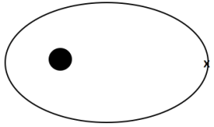
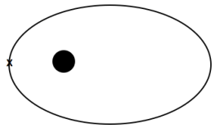
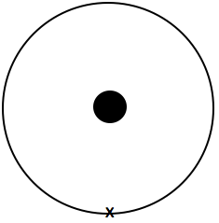
(elliptical, inside, tangent at x) (more elliptical, outside orbit, tangent at x) (less elliptical, outside orbit, tangent at x)

Orbit and Gravity Questions from A5.3
Use the value of G = 6.67x10⁻¹¹ Nm²/kg²
38,600 N  44.5 kg  2.53x10²⁴ kg  2.43x10⁶ s | 1. a. What is the force of gravity between a 6.50x10¹⁶ kg asteroid and a 18,700 kg spaceship if their centers are 1,450 m distant?  b. The centers of two lead spheres are separated by 6.70 m. If one sphere has a mass of 56.0 kg, and there is an attractive force of 3.70x10⁻⁹ N, what is the mass of the other sphere?  c. You are orbiting the planet Qwrmczl at a radius of 1.45x10⁷ m, at a velocity of 3410 m/s. What is its mass?  d. What is the period of an orbit that is 3.90x10⁸ m from earth's center? (m = 5.97x10²⁴ kg)
7.68 N  175 m  5.31x10²³ kg  5.38x10¹¹ m | 2. a. What is the force of gravity between a 2.60x10¹³ kg asteroid and a 56,100 kg spaceship if their centers are 3,560 m distant?  b. What distance separates the centers of two lead spheres if one has a mass of 123 kg, the other a mass of 12.0 kg and there is an attractive force of 3.20x10⁻¹² N?  c. You are orbiting the planet Wnnydrydrl at a radius of 7.80x10⁶ m, and a period of 2.30x10⁴ seconds. What is the planet’s mass?  d. What is the radius of an orbit around earth (m = 5.97x10²⁴ kg) that has an orbital velocity of 27.2 m/s?
3,980 N  2.84 kg  2.51x10⁸ m  4.89x10⁵ s | 3. a. What is the force of gravity between a 2.10x10¹⁵ kg asteroid and a 23,800 kg spaceship if their centers are 915 m distant?  b. The centers of two lead spheres are separated by 1.35 m. If one sphere has a mass of 125 kg, and there is an attractive force of 1.30x10⁻⁸ N, what is the mass of the other sphere?  c. What is the radius of the orbit that has an orbital velocity of 1260 m/s around the earth? (m = 5.97x10²⁴ kg)  d. What is the period of an orbit with a radius of 3.10x10⁷ m around the moon? (Moon’s mass is 7.36x10²² kg)
72.4 N  1.67 m  2.92x10⁵ s  7.54x10²⁵ kg | 4. a. What is the force of gravity between a 2.30x10¹⁴ kg asteroid and a 12,700 kg spaceship if their centers are 1,640 m distant?  b. What distance separates the centers of two lead spheres if one has a mass of 215 kg, the other a mass of 125 kg and there is an attractive force of 6.40x10⁻⁷ N?  c. What is the period of the orbit that has a radius of 9.50x10⁷ m around the earth? (m = 5.97x10²⁴ kg)  d. You orbit the planet Kssnndnnwrr at a radius of 8.20x10⁷ m with a velocity of 7830 m/s. What is its mass?
40.0 N  9.60 kg  986 m/s  2.15x10²³ kg | 5. a. What is the force of gravity between a 23.6x10¹² kg asteroid and a 14,600 kg spaceship if their centers are 758 m distant?  b. The centers of two lead spheres are separated by 4.90 m. If one sphere has a mass of 45.0 kg, and there is an attractive force of 1.20x10⁻⁹ N, what is the mass of the other sphere?  c. What is the velocity of the orbit that has a radius of 4.10x10⁸ m around the earth? (m = 5.97x10²⁴ kg)  d. You are in an orbit with a radius of 8.50x10⁷ m and a period of 1.30x10⁶ s around the planet Rjxnstdnnr. What is its mass?

Questions: Answers:
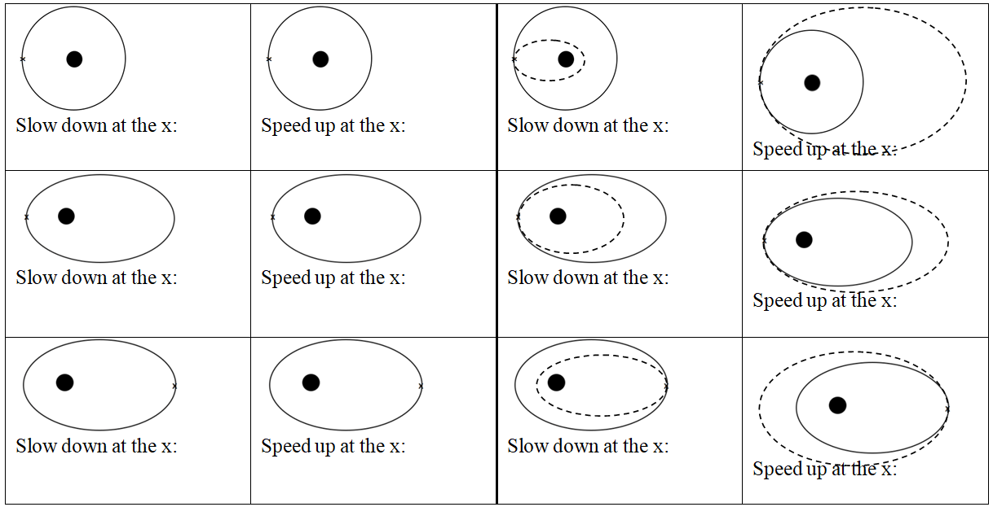
In general, speeding up brings the far side out, slowing down brings the far side in. Speeding up brings the entire trajectory outside the old one, and slowing down brings entire trajectory inside the old one.

